**Q1.** To Study basic and User status Unix/Linux Commands.

**1. Directory & File Management**

* **ls** - Lists files and directories.
  + ls : Lists all files and directories.
  + ls -a : Lists all files, including hidden files.
  + ls -l : Lists files with details (permissions, owner, size, etc.).
  + ls -lsh : List files with sizes, permissions, and hidden files
* **du** – Check File sizes.
  + du -sh * : List all normal files with size.
  + du -sh .[^.]* : List all hidden files with sizes.
  + du -sh .[^.]* * : List all files with sizes(including hidden files)
* **cd** - Changes directories.
  + cd /path/to/directory: Navigate to a specified directory.
  + cd ~: Goes to the home directory.
  + cd ..: Moves up one directory level.
* **wc** - File content Counting.
  + wc filename : Displays the number of lines, words, and characters in a file.
  + wc -l filename : Count lines in a file.
  + wc -w filename : Count words in a file.
  + wc -c filename : Count characters in a file.
* **pwd** - Prints the current working directory.
* **mkdir** - Creates a new directory.
  + mkdir directory_name: Creates a directory named directory_name.
* **rmdir** - Removes an empty directory.
  + rmdir directory_name: Deletes an empty directory.

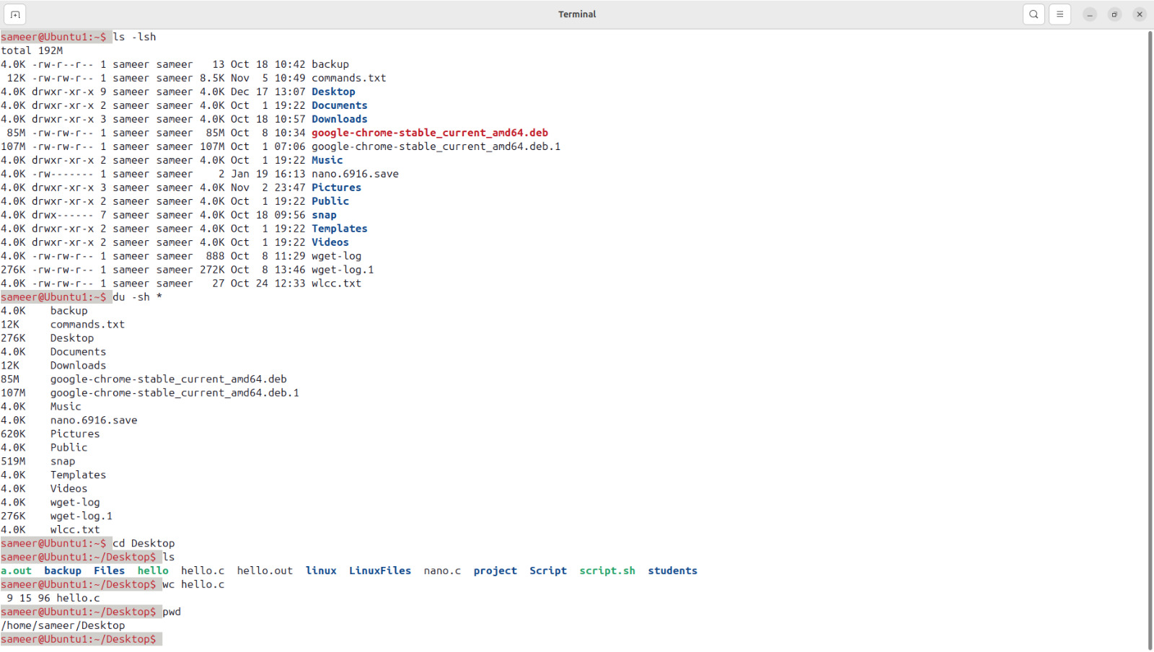

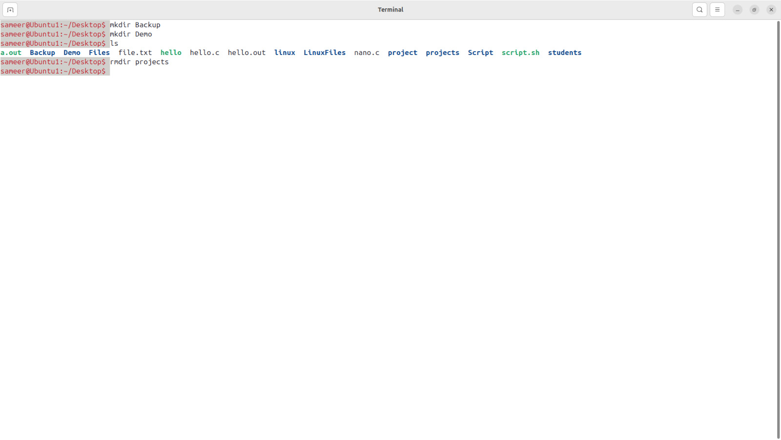

* **cp** - Copies files or directories.
  + cp filename path/to/destination: Copies a file from source to destination.
  + cp -r source_dir destination_dir: Copies directories recursively.
* **mv** - Moves or renames files/directories.
  + mv old_filename new_filename: Renames a file or directory.
  + mv filename /path/to/destination: Moves a file to a specified directory.
* **rm** - Deletes files or directories.
  + rm filename: Deletes a file.
  + rm -r directory_name: Deletes a directory and its contents recursively.
* **touch** - Creates an empty file or updates a file's timestamp.
  + touch file_name: Creates a new, empty file.

**2. File Content Viewing & Manipulation**

* **cat** - Concatenates and displays file contents.
  + cat filename: Displays contents of a file.
  + cat file1 file2 > newfile: Concatenates two files into a new file.
* **echo** - Displays text or variable values.
  + echo "Hello, World!": Prints text to the terminal.
  + echo $HOME: Displays the value of the HOME environment variable.
* **head** - Displays the first few lines of a file.
  + head filename: Shows the top lines of a file.
* **tail** - Displays the last few lines of a file.
  + tail filename: Shows the bottom lines of a file.
* **more** & **less** - Paginates file content for easy reading.
  + more filename: Scrolls through a file one screen at a time.

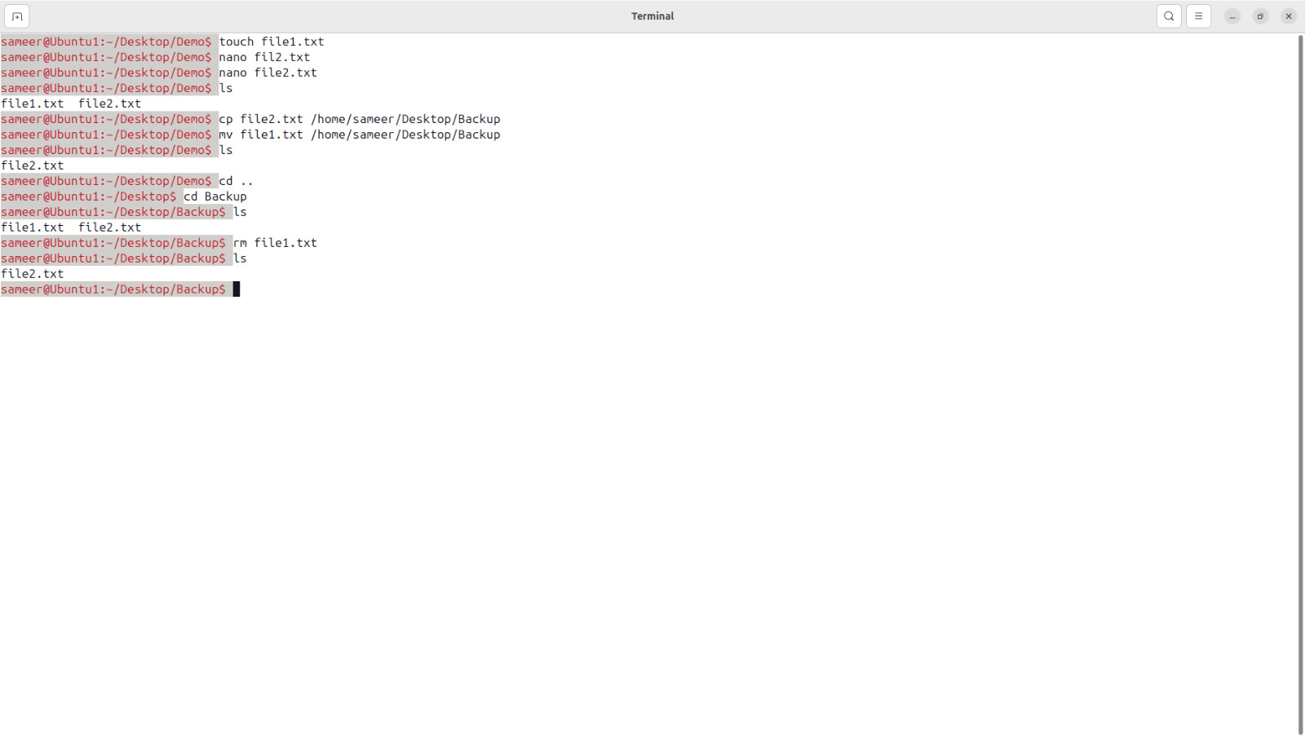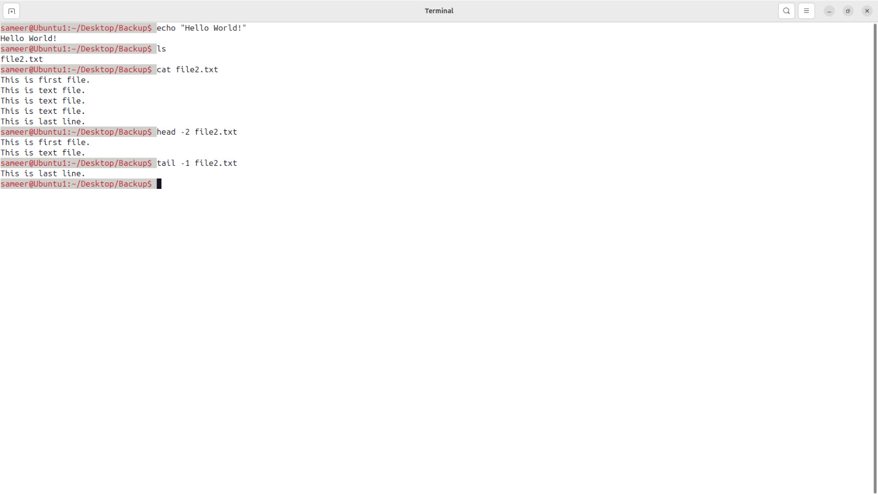

* + less filename: Allows forward and backward scrolling.
* **nano**, **vi**, **vim** - Text editors to create or modify files.
  + nano filename, vi filename, vim filename

**3. File comparison**

* **diff** - Compares two files line by line and outputs the differences between them.
  + diff file1.txt file2.txt : Show difference between them.
  + diff -u file1.txt file2.txt : Unified format, which provides a more readable output
  + diff -u file1.txt file2.txt : Ignores case differences.
  + diff -u file1.txt file2.txt : Ignores white spaces.
* **cmp** - Compares two files byte by byte. It’s more suitable for binary files.
  + cmp file1.txt file2.txt : Basic usage.
  + cmp -l file1.txt file2.txt : Outputs the byte numbers and differing bytes in octal.
  + cmp -s file1.txt file2.txt : Suppresses all output, just returns a status code (0 if files are identical, 1 if different).
* **comm :** compares two sorted files line by line and outputs three columns: lines unique to file1, lines unique to file2, and lines common to both files.

Make sure to sort your file before using comm

* sort filename > sorted_filename
  + comm -12 file1.txt file2.txt
    - -1 suppresses lines unique to the first file.
    - -2 suppresses lines unique to the second file.
    - This will print only the lines common to both files.

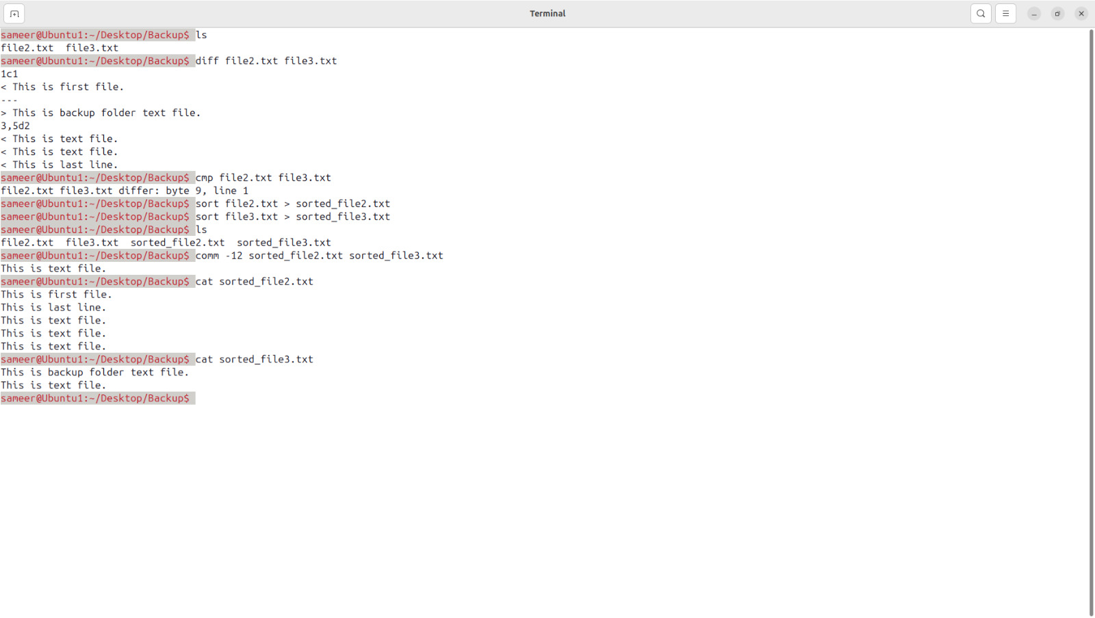

**3. User & Group Management**

* **whoami** - Displays the current logged-in user’s name.
* **who** - Lists all users currently logged in.
* **w** - Shows detailed info about logged-in users and what they’re doing.
* **id** - Shows user and group IDs.
  + id username: Displays IDs of a specified user.
* **groups** - Displays groups the user belongs to.
  + groups username: Shows groups for a specified user.
* **finger** - Provides information about a user (if available).
  + finger username: Shows info for a specified user.

**4. Process Management**

* **ps** - Shows running processes.
  + ps aux: Shows current running processes with details.
* **top** - Opens a real-time view of system processes.
* **kill** - Terminates a process.
  + kill PID: Kills the process with the specified PID.
  + kill -9 PID: Forcefully kills a process.
* **jobs** - Lists background jobs.
* **bg** & **fg** - Manages jobs in the background or foreground.
  + bg %job_number: Moves a job to the background.
  + fg %job_number: Brings a job to the foreground.

**5. System Monitoring & Status**

* **uptime** - Displays system uptime and load.
* **df** - Shows disk usage by filesystem.
  + df -h: Shows disk usage in human-readable format.

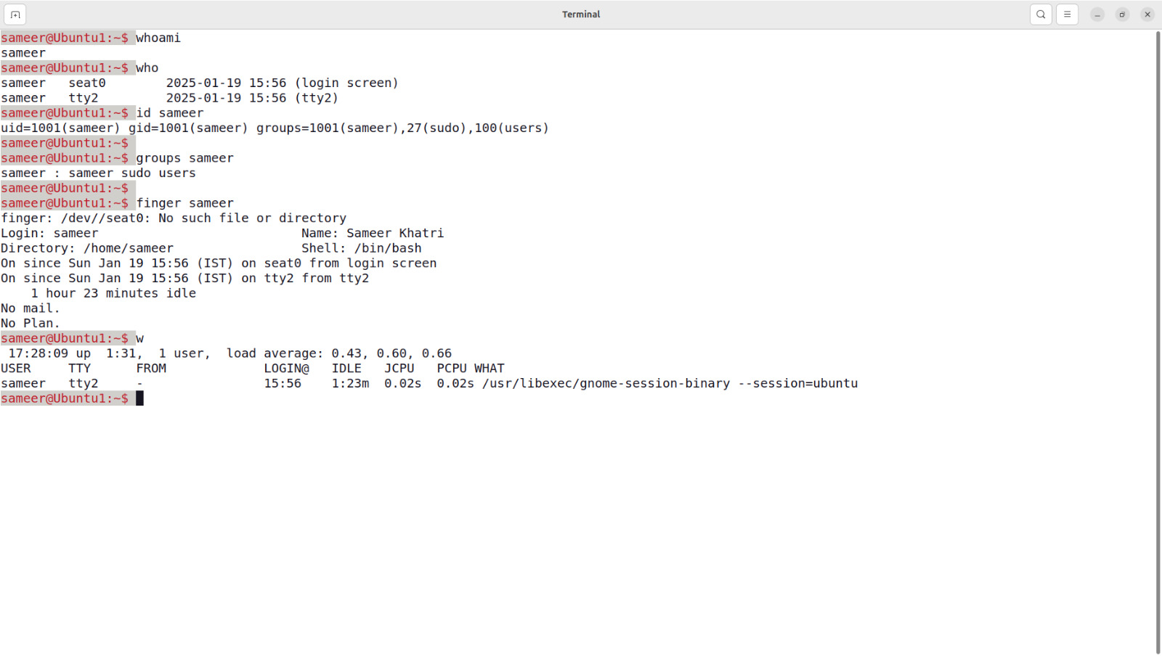

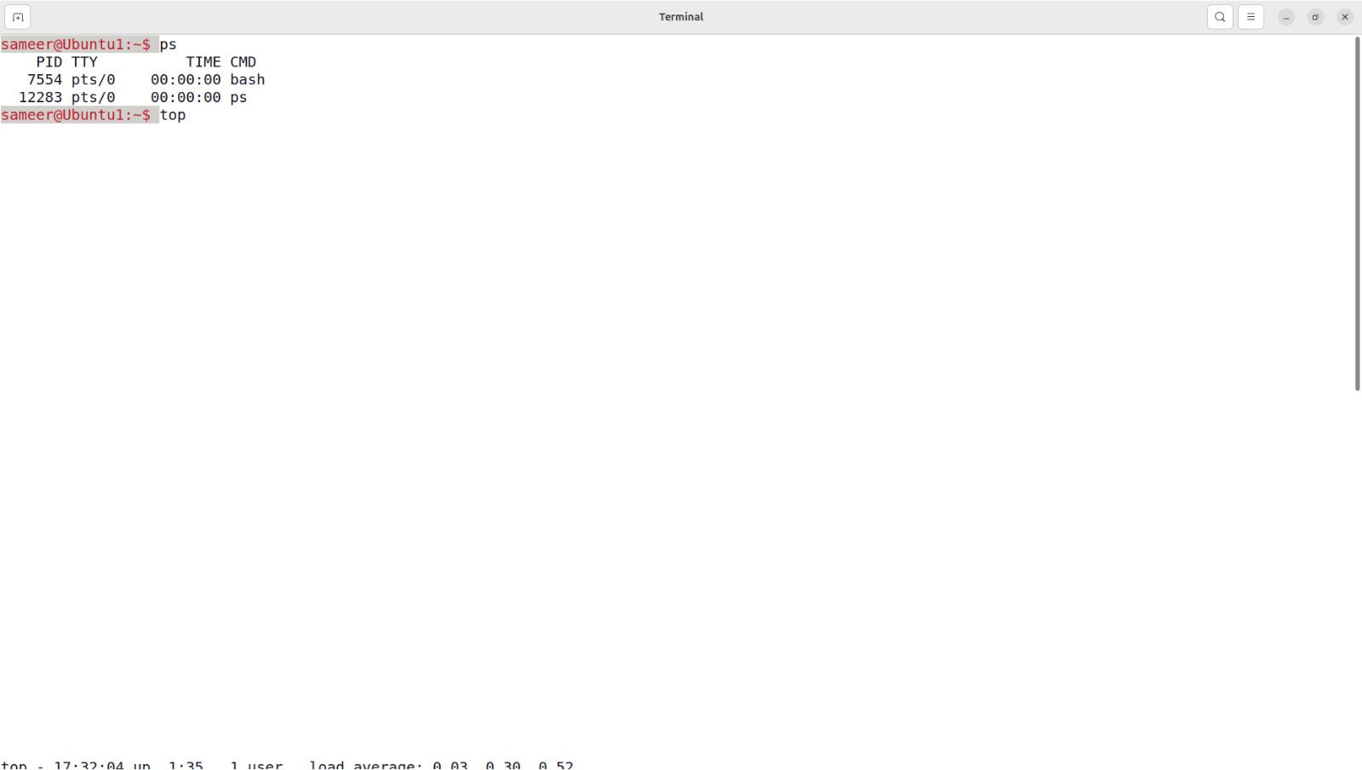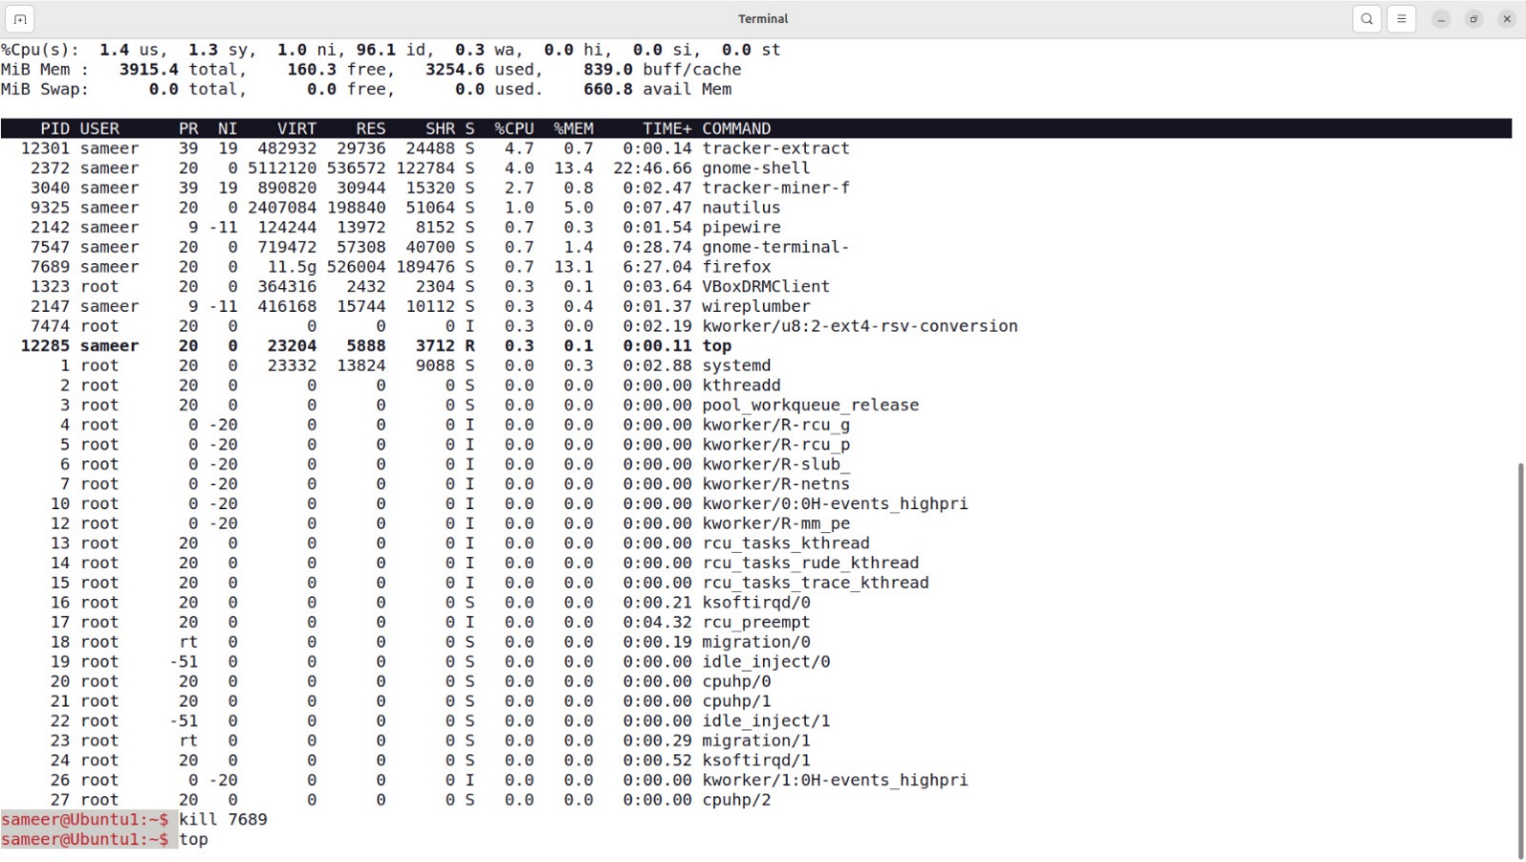

* **du** - Shows disk usage of files and directories.
  + du -h directory: Shows disk usage for a directory.
* **free** - Shows memory usage.
  + free -h: Shows memory in human-readable format.
* **last** - Shows login history.
* **uname** - Displays system information.
  + uname -a: Shows all system information.
* **dmesg** - Displays system boot and hardware messages.
* **iostat**, **vmstat** - Displays CPU, disk I/O, and memory statistics.
  + iostat: Shows I/O statistics.
  + vmstat: Shows virtual memory statistics.

**6. Network Management**

* **ping** - Tests connectivity to a server.
  + ping hostname: Sends ping requests to hostname.
* **ifconfig** - Displays network interface configuration.
  + ifconfig: Shows all network interfaces.
* **netstat** - Shows network connections, routing tables, etc.
* **ssh** - Connects to a remote server via SSH.
  + ssh user@hostname: SSH into a remote server.
* **scp** - Securely copies files to/from a remote server.
  + scp file user@hostname:/path/to/destination: Copies a file to a remote server.
* **curl** & **wget** - Fetches files or data from a URL.
  + curl url: Retrieves data from a URL.
  + wget url: Downloads a file from a URL.

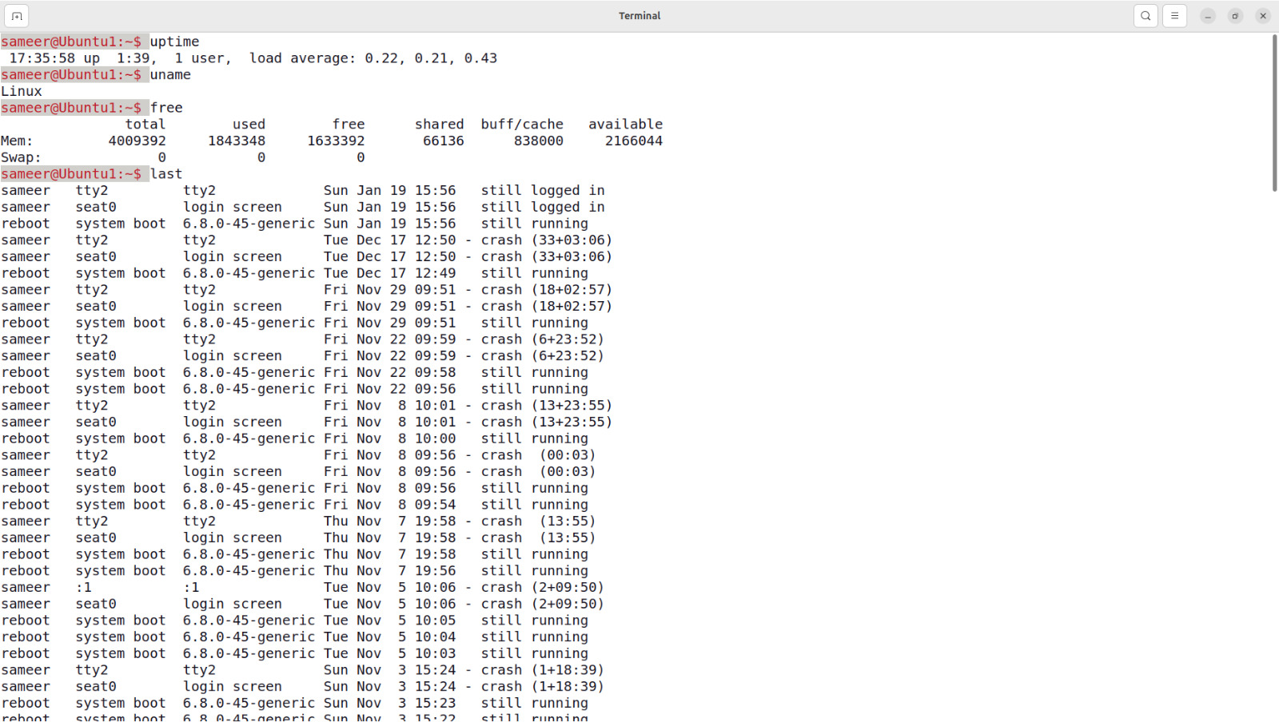

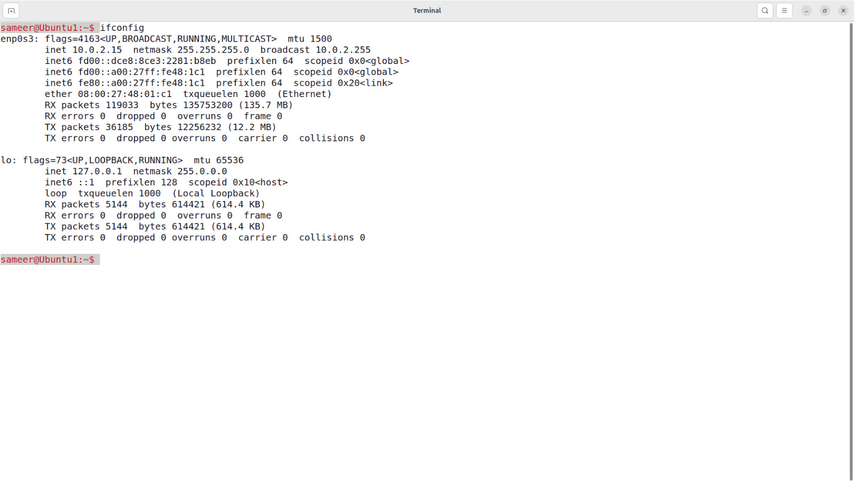

**7. Searching & Finding Files**

* **find** - Searches for files and directories.
  + find /path -name filename: Searches for a file by name.
  + sudo find / -type f -name "file.txt" : Search for a File Across the System.
* **grep** - Searches within files for patterns.
  + grep "pattern" filename: Searches for a pattern(word) in a file.
* **locate** - Quickly finds files (needs an updated database).
  + locate filename: Finds files by name.
* **which** - Shows the path of a command.
  + which command: Shows the full path of a command.

**8. Permissions & Ownership**

* **ls** – Check file permission.
  + ls -ld filename : Check file permissions.
* **chmod** - Changes file permissions.
  + chmod 755 filename: Sets permissions to 755 for a file.
  + chmod +rwx file.txt : Add read, write, and execute permissions.
  + chmod -rwx file.txt : Remove read, write, and execute permissions.
* **chown** - Changes file owner and group.
  + chown user:group filename: Changes ownership of a file.
* **chgrp** - Changes group ownership.
  + chgrp group filename: Changes group of a file.

**9. Compression & Archiving**

* **tar** - Archives multiple files into one.
  + tar -cvf archive.tar directory/: Creates an archive.

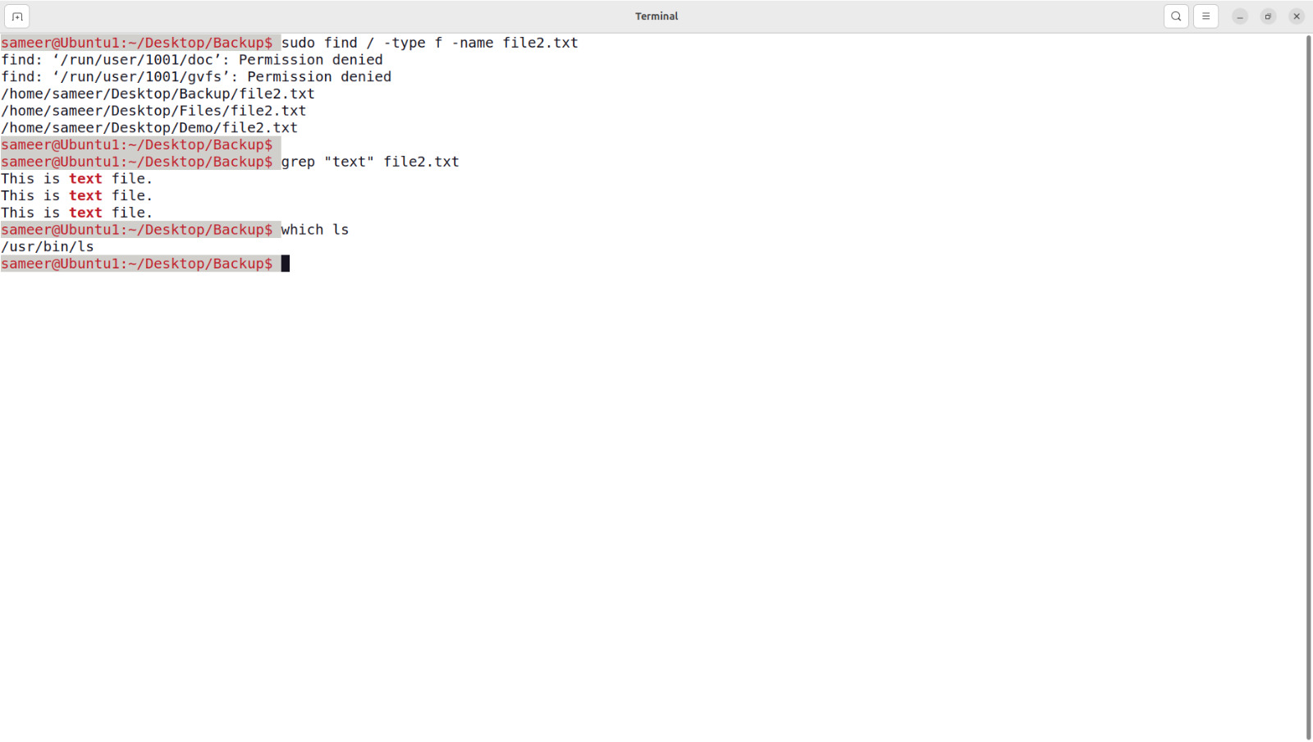

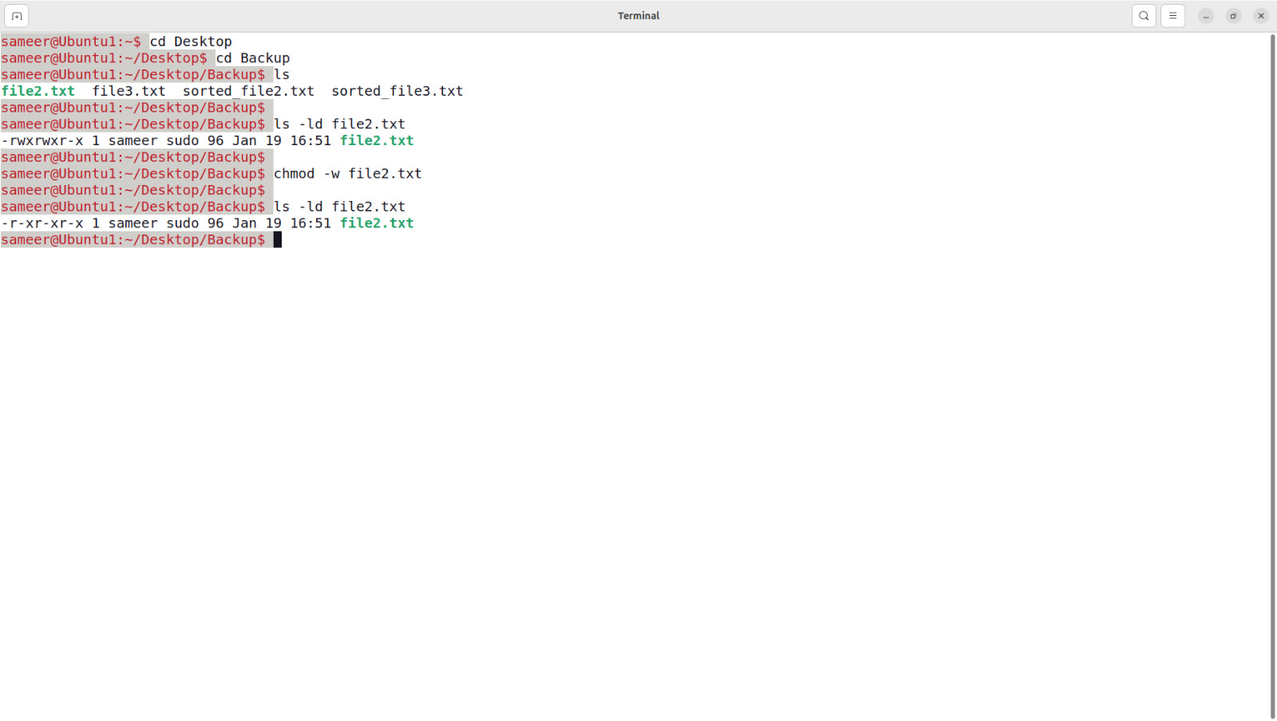

* + tar -xvf archive.tar: Extracts an archive.
* **gzip** & **gunzip** - Compresses and decompresses files.
  + gzip filename: Compresses a file.
  + gunzip filename.gz: Decompresses a file.
* **zip** & **unzip** - Compresses and decompresses zip files.
  + zip archive.zip file1 file2: Creates a zip archive.
  + unzip archive.zip: Extracts a zip archive.

**10. Disk Space**

* **ls** – Check dish usage.
  + ls -h : Check Free Disk Space.
  + ls -h –total : View Total Disk Space,
  + ls > path/to/destination : Redirect Command Output to a file.

**11. System Information**

* **free** : Check Total memory usage.
  + free -h : Check Total Memory Usage.
* **htop** : Monitor Process and Memory Usage.
  + sudo install htop ,then htop : Install and use htop for an interactive view.

**12. Network Configuration**

* ifconfig : Displays network configuration (deprecated in favor of ip)
* ip addr : Shows IP addresses assigned to the system.
* netstat : Displays network connections, routing tables, and interface statistics.

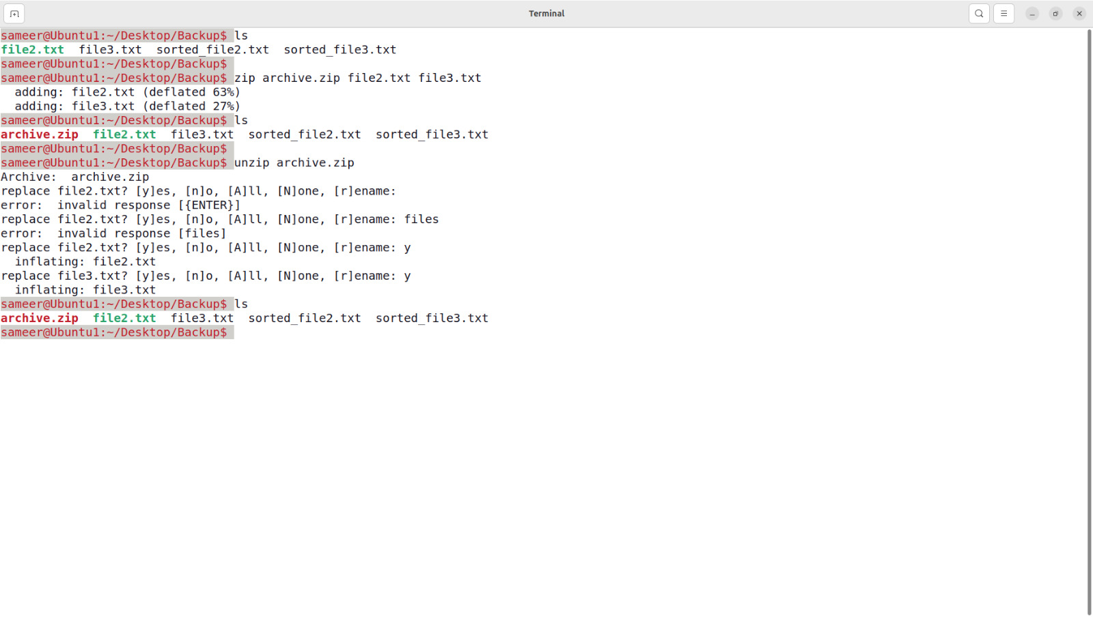

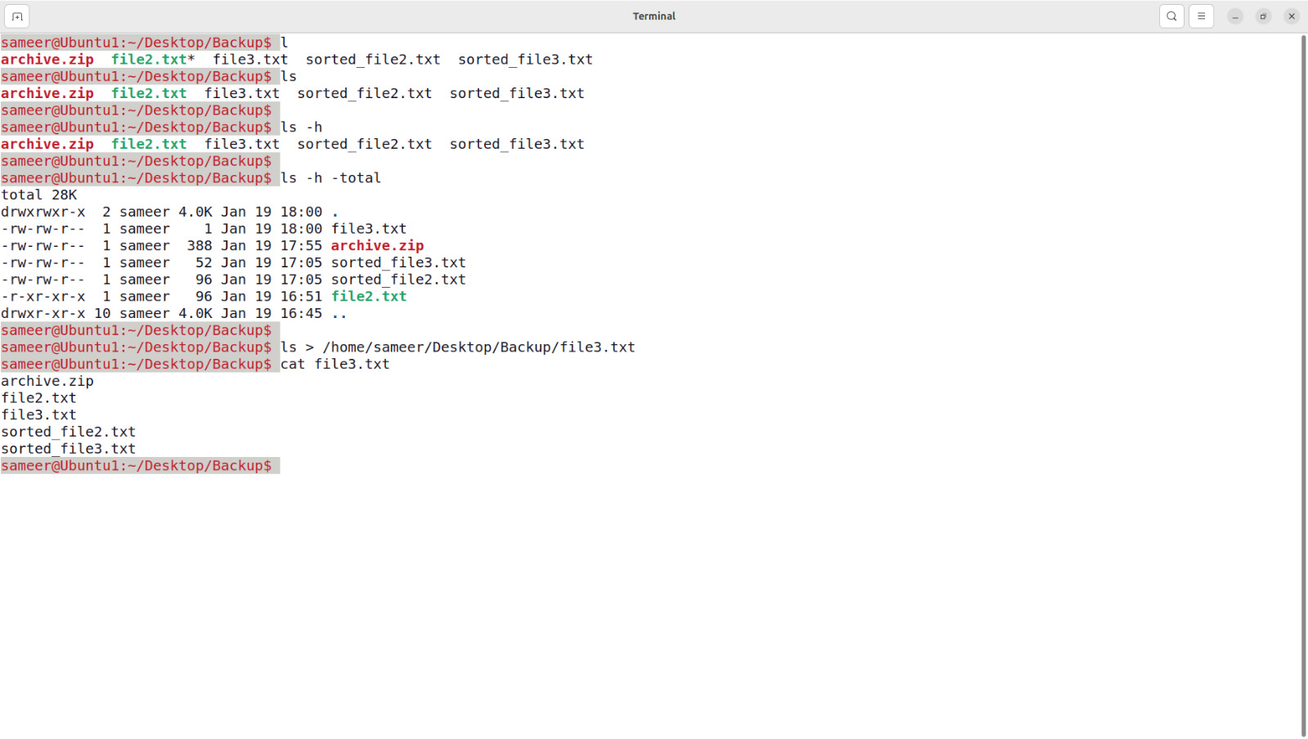

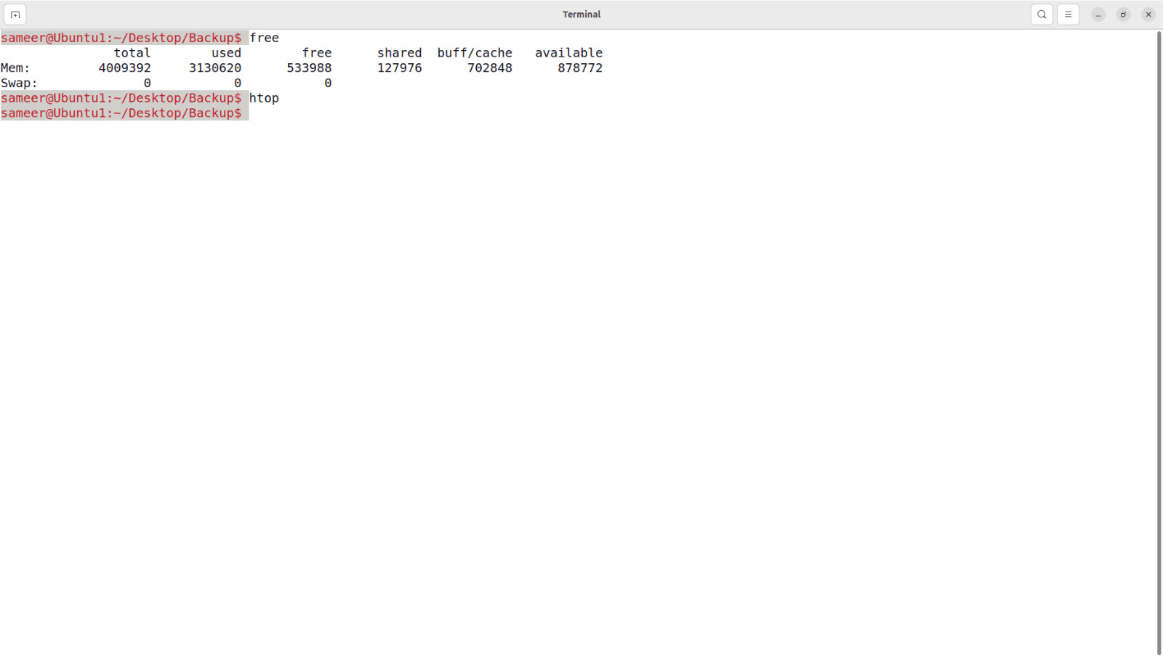

**13. System Information**

* uname -a: Displays system information (kernel version, architecture).
  + hostname : Shows the system's hostname.
  + uptime: Shows how long the system has been running

**14. User Management**

* **Basic user management**.
  + sudo adduser username : Add a ner user.
  + sudo deluser username : delete a user.
  + sudo deluser --remove-home username : To delete the user and their home directory
  + sudo passwd username : change user’s password.
  + su – username : Switches to another user in terminal.
* **User Information**
  + Id username : Shows the user ID, group ID, and other details.
  + who : List currently logged in user.
  + cat/etc/passwd : Lists all user accounts on the system.
  + last username : Shows the last login details of a specific user.
* **User Group Management**
  + sudo groupadd groupname : Adds a new user group to the system.
  + sudo usermod -aG groupname username : Adds an existing user to a specific group.
  + sudo deluser username groupname : Removes a user from a specific group.
  + groups username : Shows all groups the user belongs to.

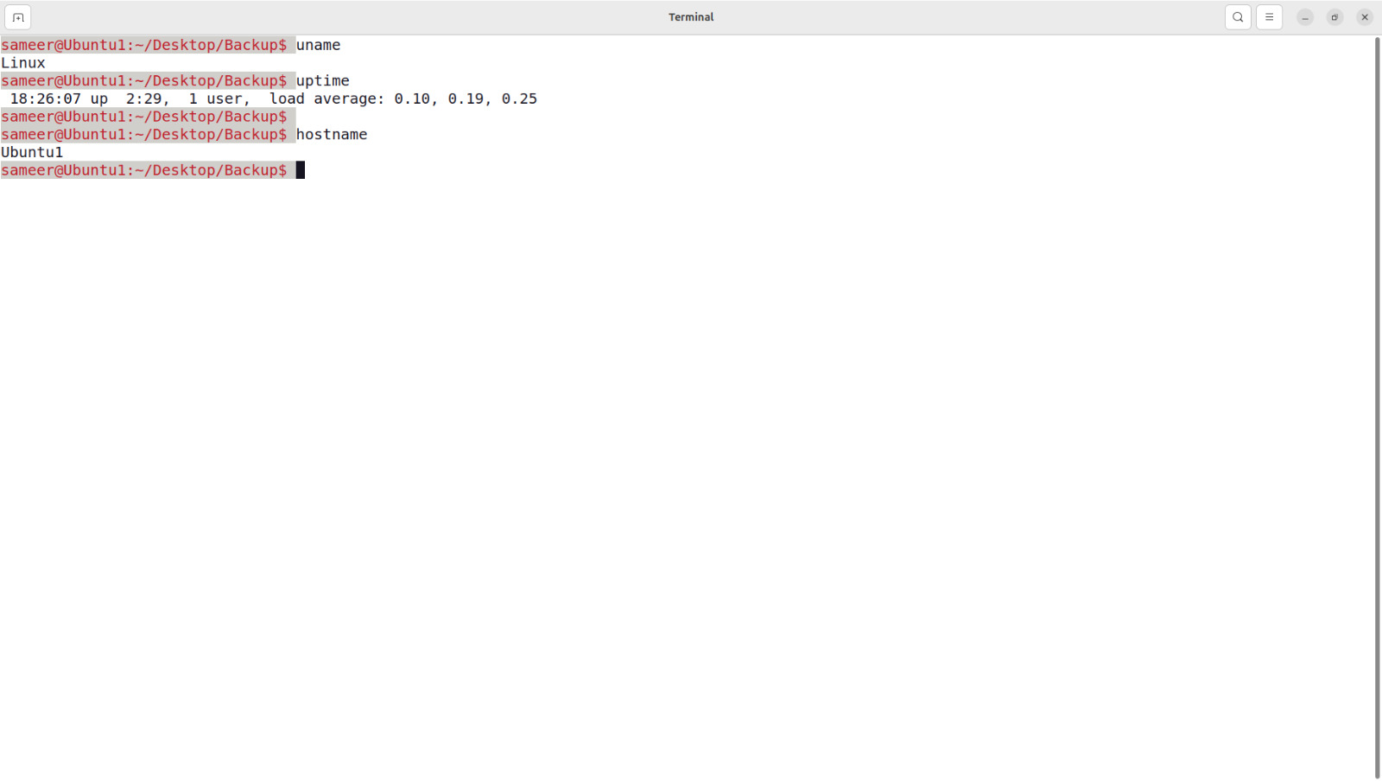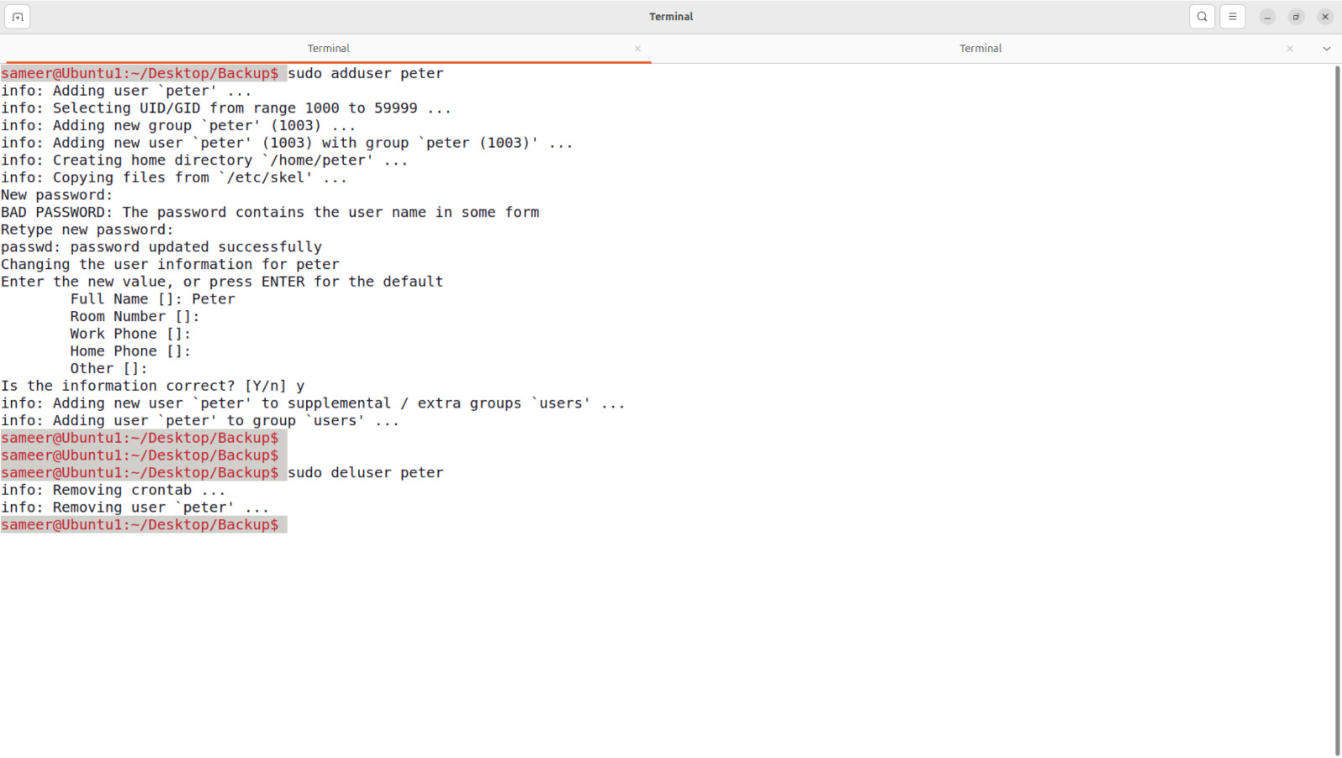

**Q2.** Study & use of commands for performing arithmetic operations with Unix/Linux.

In Ubuntu (or any Linux-based system), you can perform basic arithmetic operations using various tools. Here are a few methods.

**1. Using expr Command**

The expr command can be used for integer arithmetic.

* **Addition :**
  + expr 5 + 3
* **Subtraction :**
  + expr 5 – 3
* **Multipication**(use the escape character \ before *) :
  + expr 5 /* 3
* **Division :**
  + Expr 9 / 3
* **Modulus**(remainder) :
  + expr 5 % 3

**2. Using bc Command**

For floating-point arithmetic, you can use bc (basic calculator).

* **Addition :**
  + echo "5 + 3.5" | bc
* **Subtraction :**
  + echo "10 - 7.2" | bc
* **Multipication**(use the escape character \ before *) :
  + echo "4.5 * 2" | bc
* **Division :**
  + echo "8 / 2.5" | bc

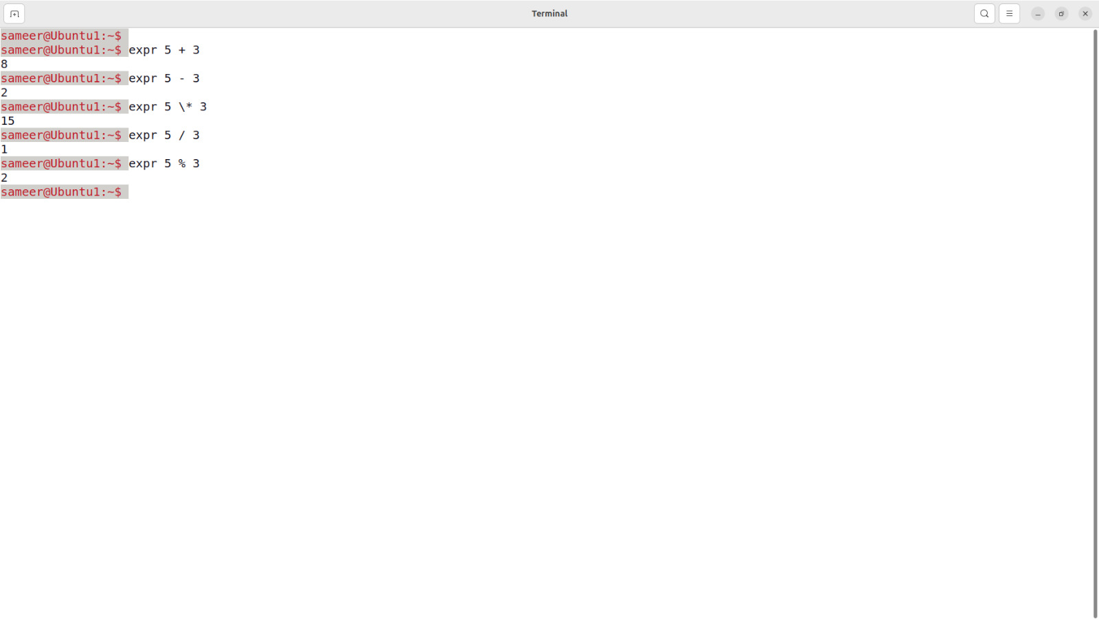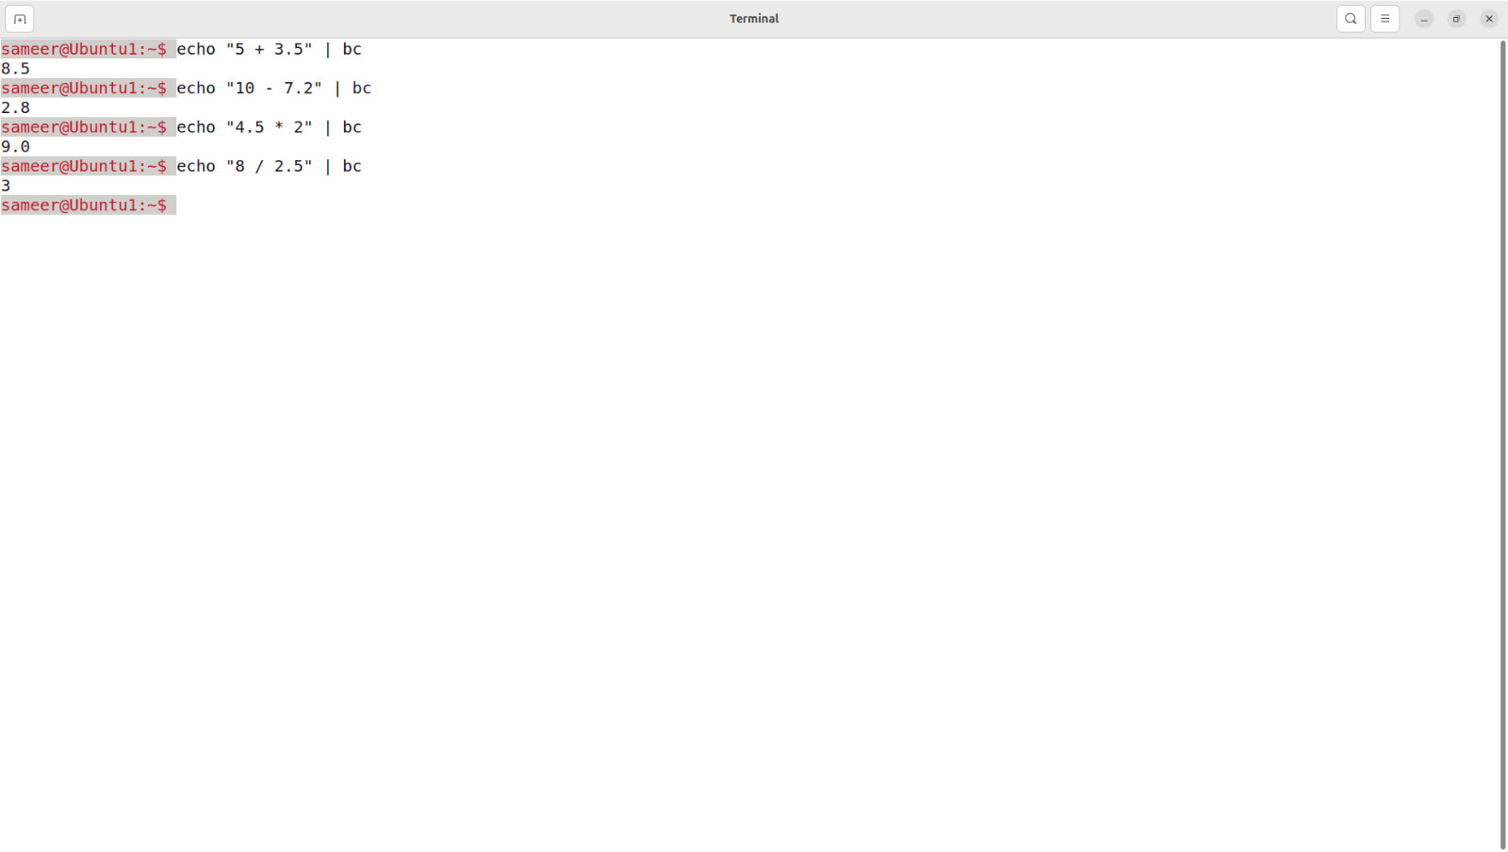

**3. Using $(( )) in Shell**

You can perform arithmetic directly in the shell using $(( )).

* **Addition :**
  + echo $((5 + 3))
* **Subtraction :**
  + echo $((10 - 7))
* **Multipication**(use the escape character \ before *) :
  + echo $((10 * 7))
* **Division :**
  + echo $((10 / 2))
* **Modulus**(remainder) :
  + echo $((10 % 3))

**Output:**

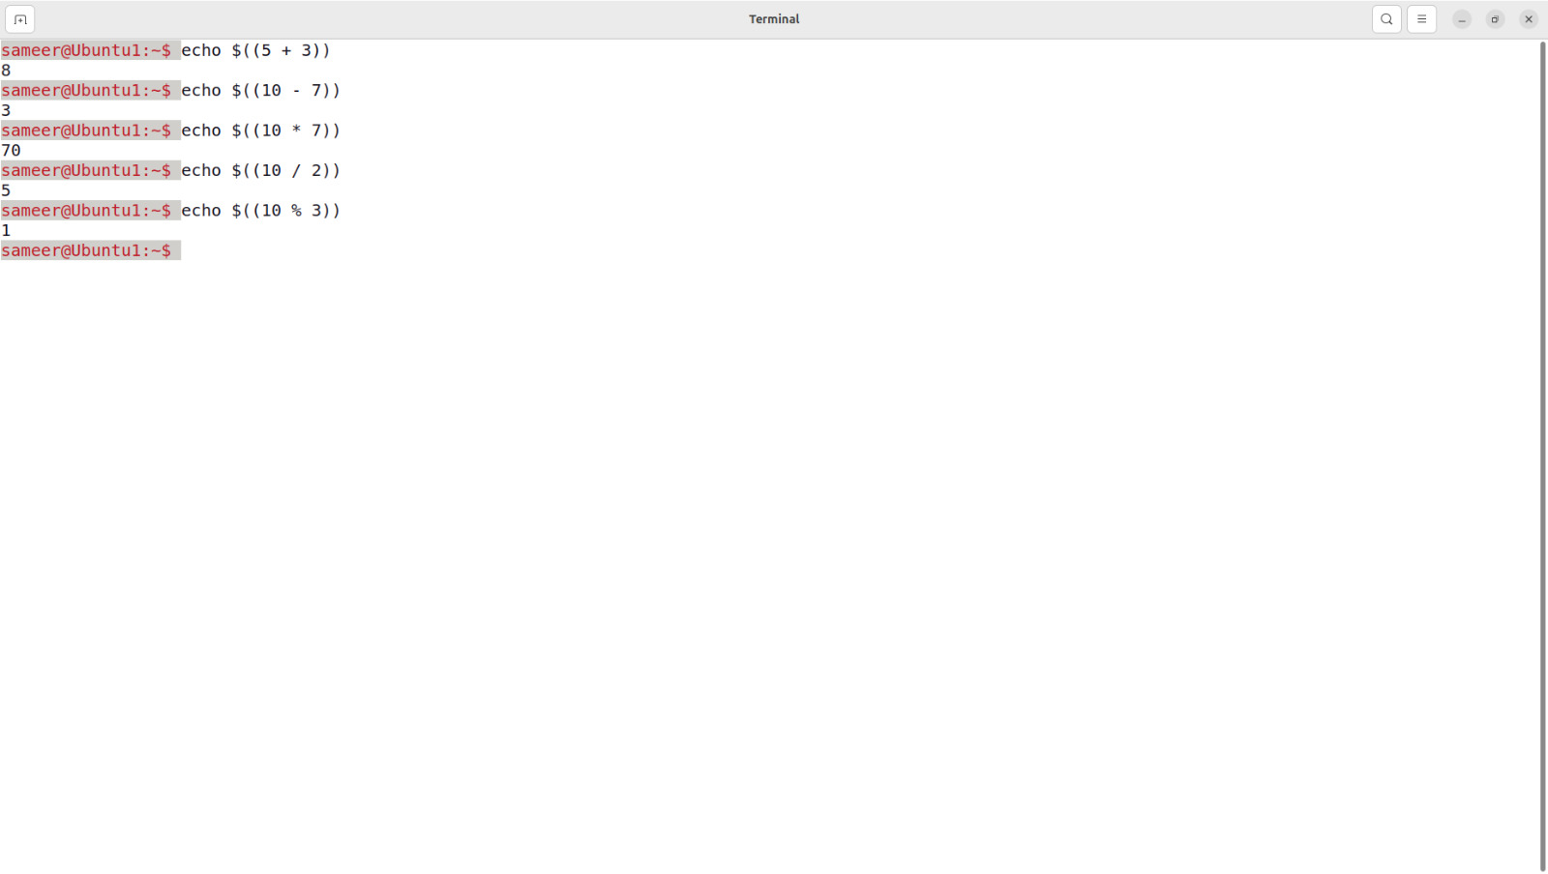

**Q3.** Create a file called wlcc.txt with some lines and display how many lines, words and characters are present in that file.

To create a file called wlcc.txt with the touch command, add some content, and then count the lines, words, and characters, follow these steps:

**1. Create a file using ‘touch’**

The touch command creates an empty file. 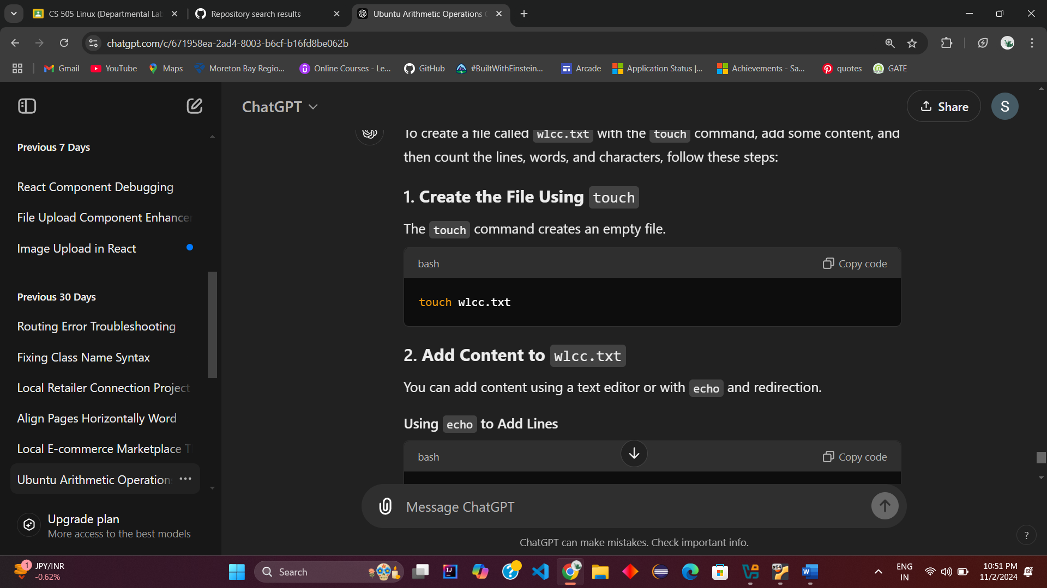

**2. Add Content to ‘wlcc.txt’**

You can add content using a text editor or with echo and redirection.

**Using echo to Add Lines**

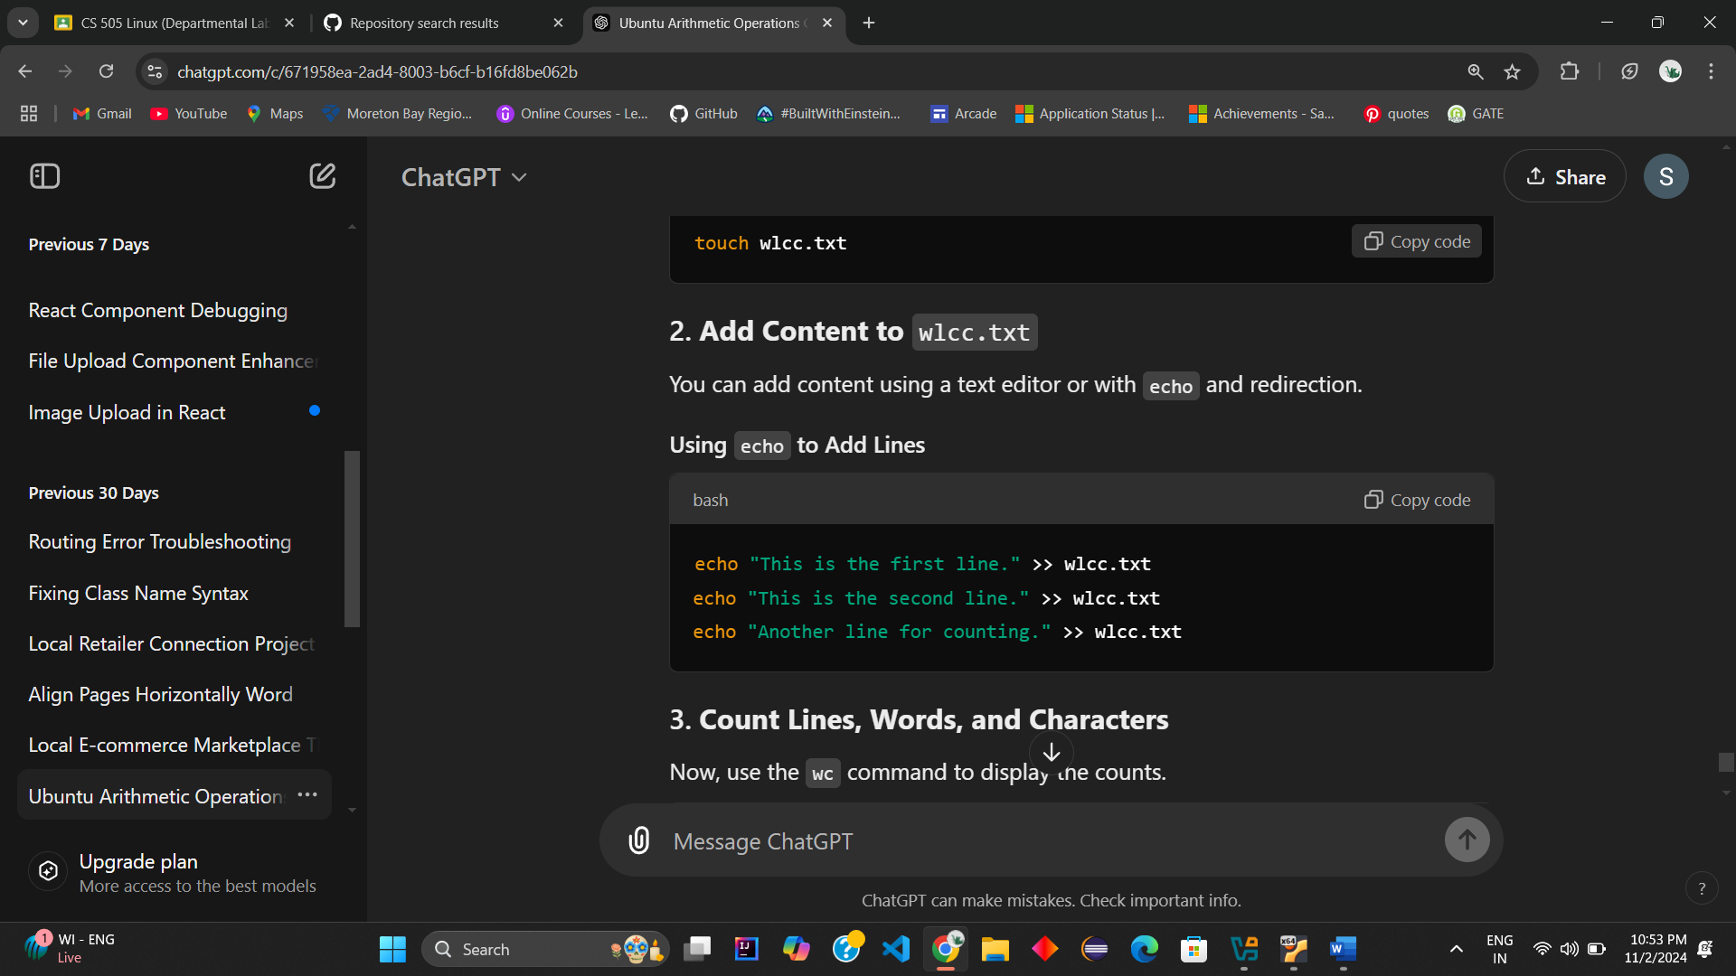

**3. Count Lines, Words, and Characters**

Now, use the wc command to display the counts.

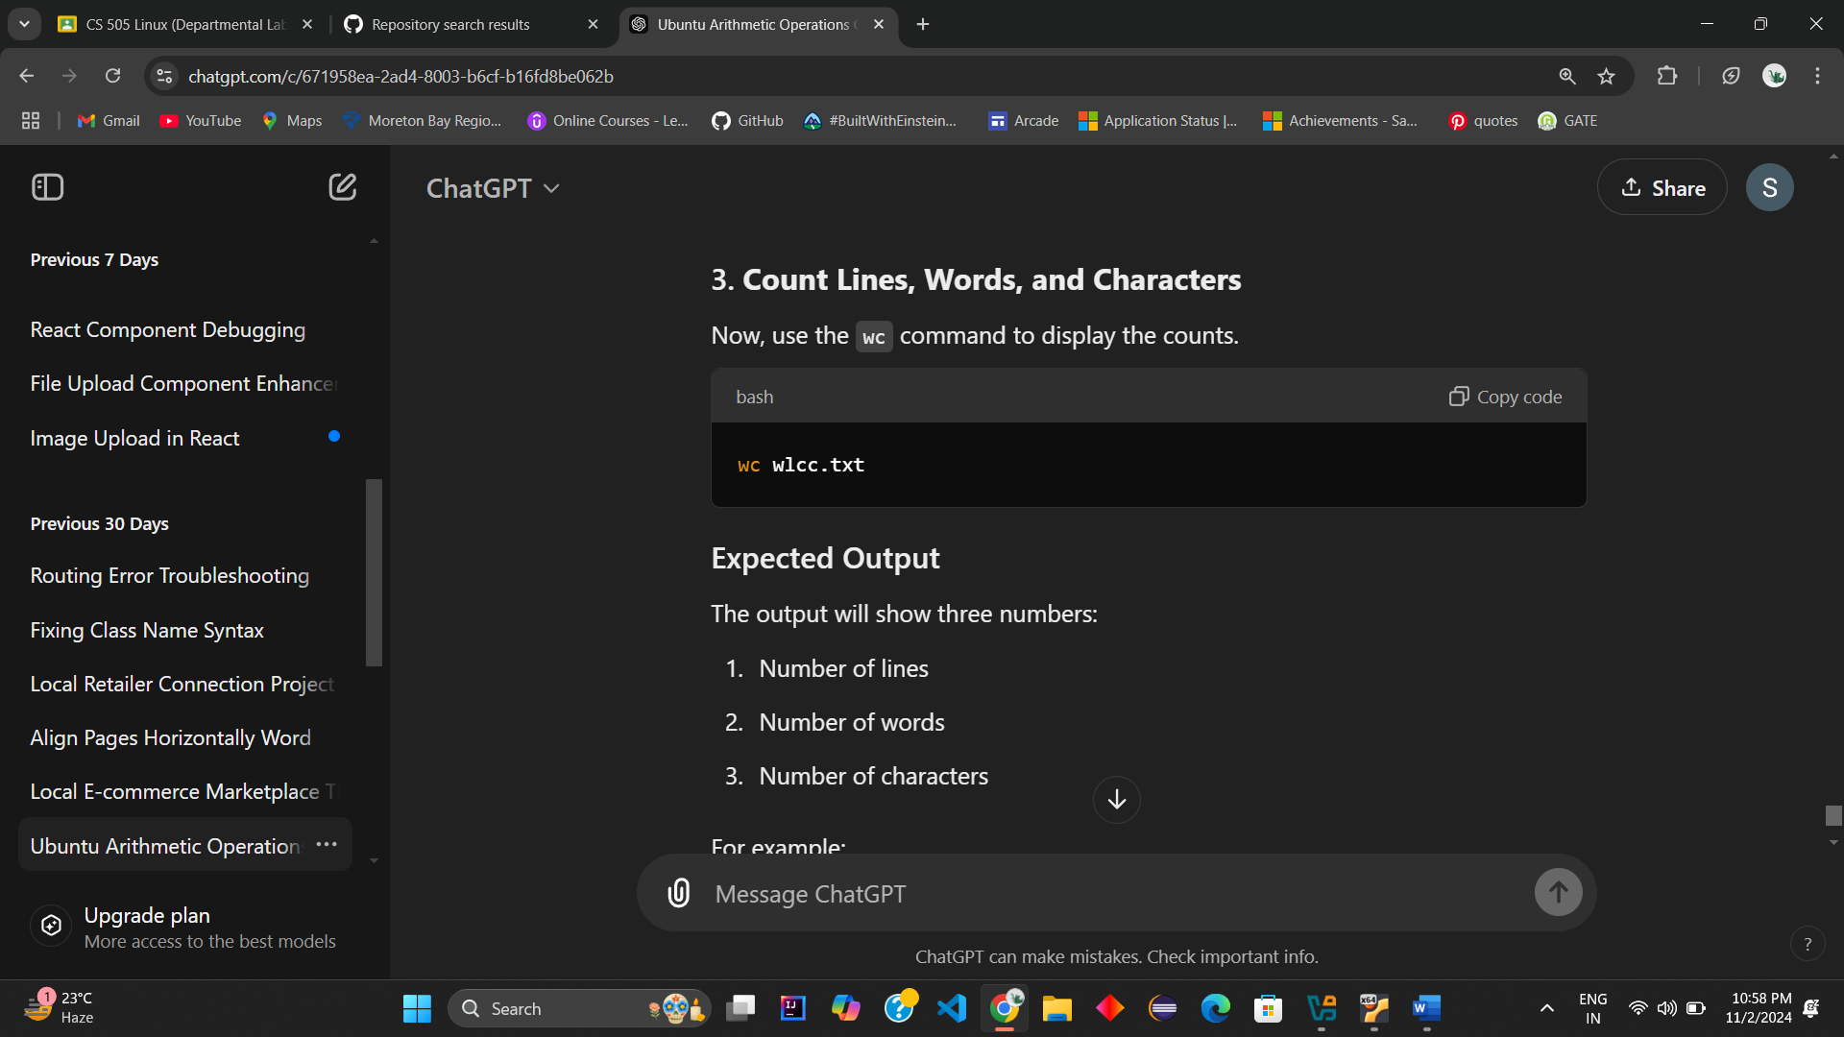

**Expected Output**

The output will show three numbers:

1. Number of lines
2. Number of words
3. Number of characters

For example:

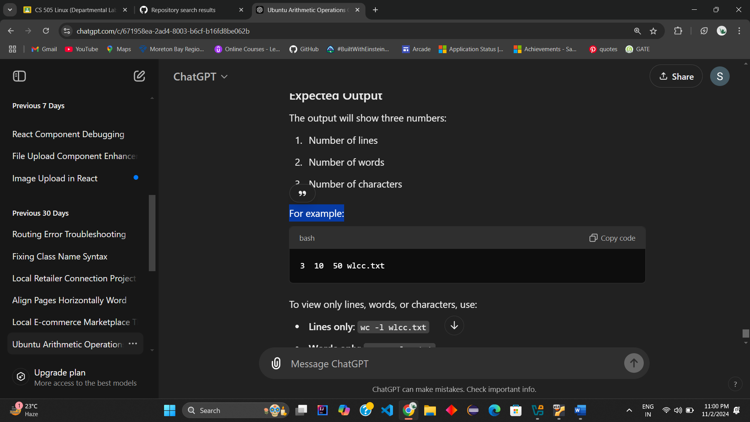

To view only lines, words, or characters, use:

* **Lines only**: wc -l wlcc.txt
* **Words only**: wc -w wlcc.txt
* **Characters only**: wc -m wlcc.txt

**Output:**

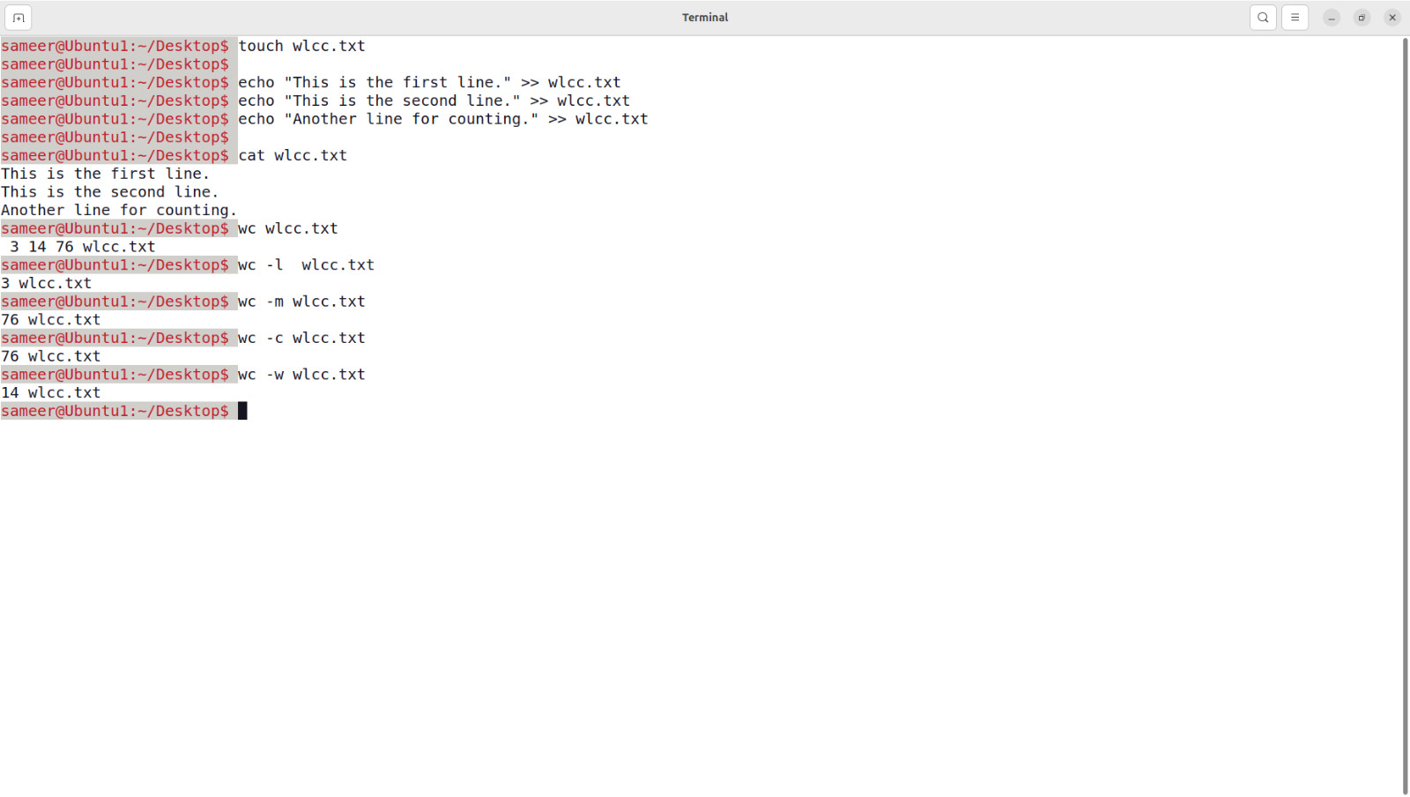

**Q4.** Append ten more simple lines to the wlcc.txt file created above and split the appended file into 3 parts. What will be the names of these split files? Display the contents of each of these files.How many lines will be there on the last file?

To append ten more lines to the wlcc.txt file, split it into three parts, and display the contents of each file along with the line count of the last file, follow these steps:

**1. Append Ten More Lines to ‘wlcc.txt’**

Use the echo command in a loop to quickly append ten simple lines to the file.

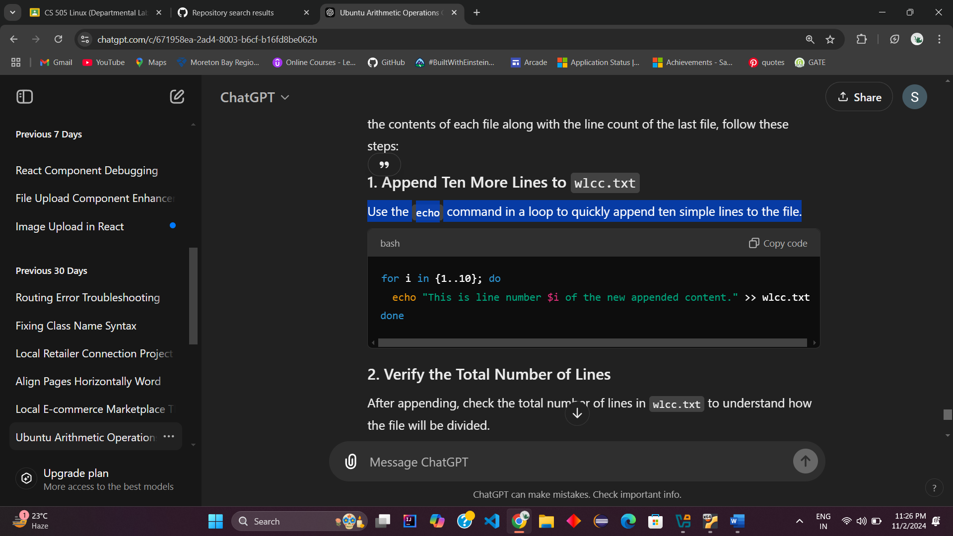

**2. Verify the Total Number of Lines**

After appending, check the total number of lines in wlcc.txt to understand how the file will be divided.

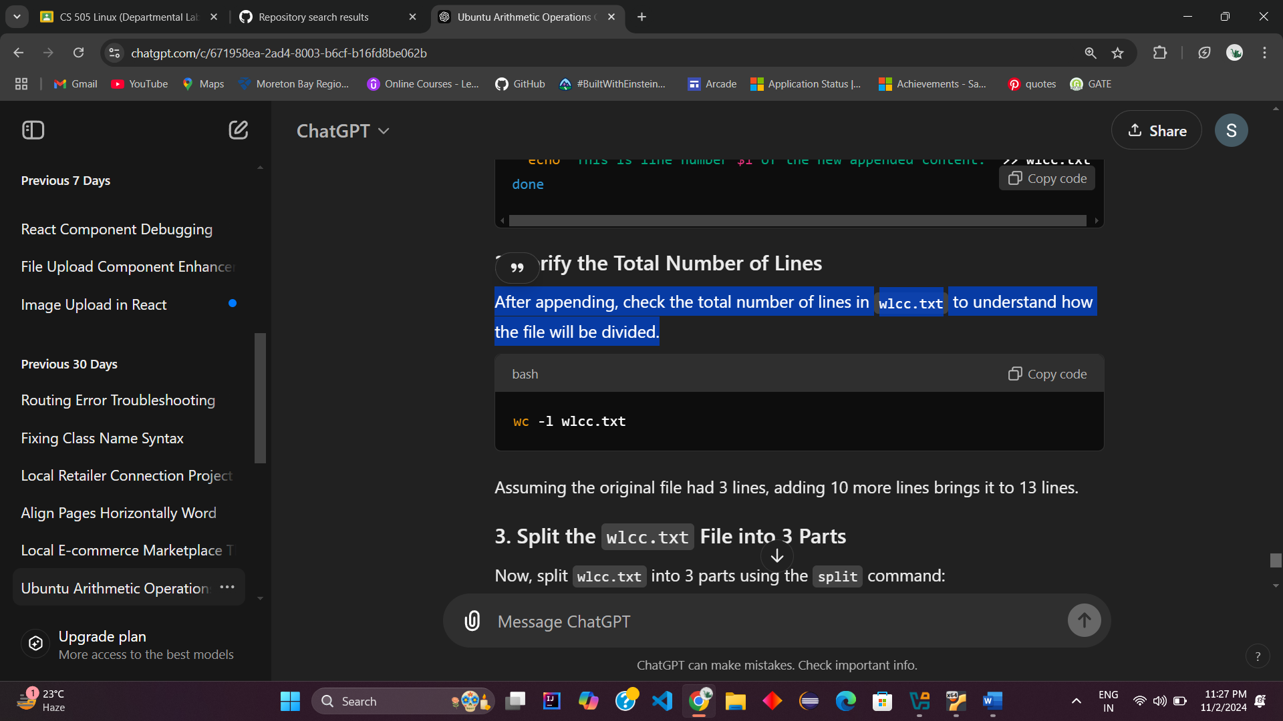

Assuming the original file had 2 lines, adding 10 more lines brings it to 12 lines.

**3. Split the wlcc.txt File into 3 Parts**

Now, split wlcc.txt into 3 parts using the split command:

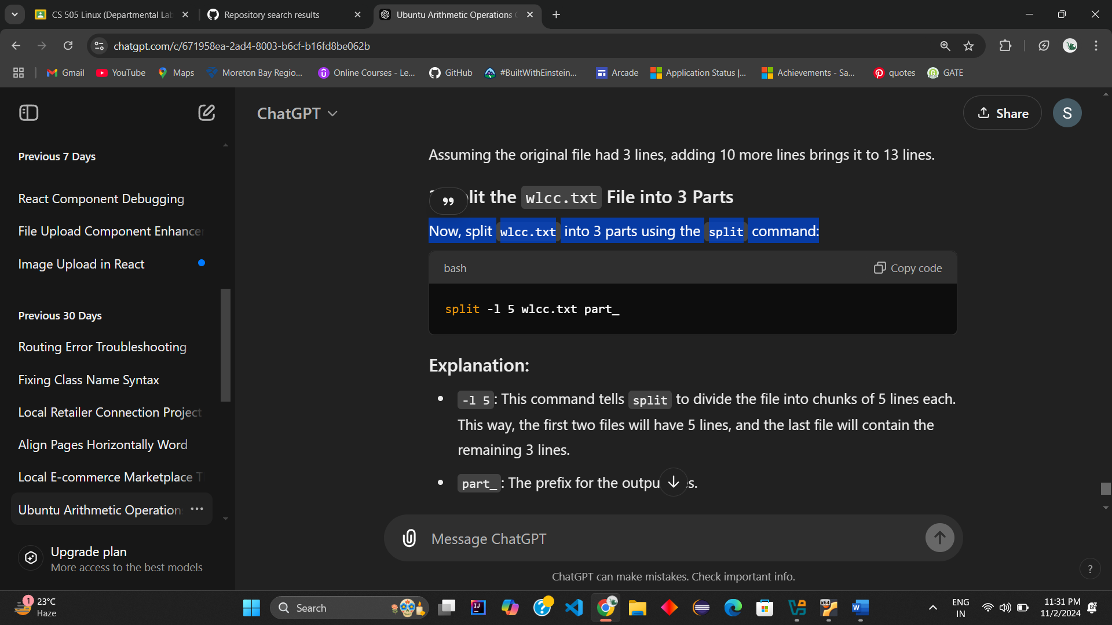

**Explanation:**

* -l 5: This command tells split to divide the file into chunks of 5 lines each. This way, the first two files will have 5 lines, and the last file will contain the remaining 2 lines.
* part_: The prefix for the output files.

**4. Resulting Split Files**

The files will be named part_aa, part_ab, and part_ac. Here’s what they contain:

* **part_aa**: First 5 lines of wlcc.txt
* **part_ab**: Next 5 lines of wlcc.txt
* **part_ac**: Last 2 lines of wlcc.txt (since 13 total lines / 3 parts leaves 2 remaining lines)

**6. Number of Lines in the Last File**

Since wlcc.txt had a total of 13 lines, and each part is split by 5 lines, the last file (part_ac) will contain **3 lines**.

**5. Display the Contents of Each Split File**

Use cat to view the contents of each file.

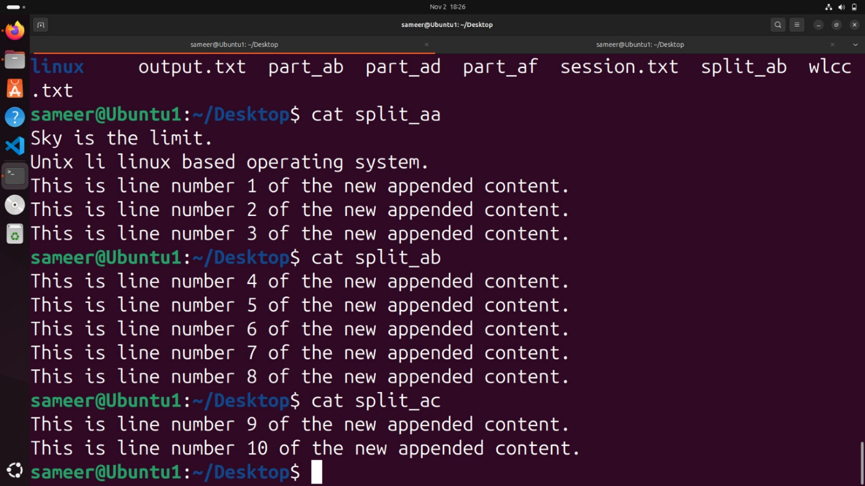

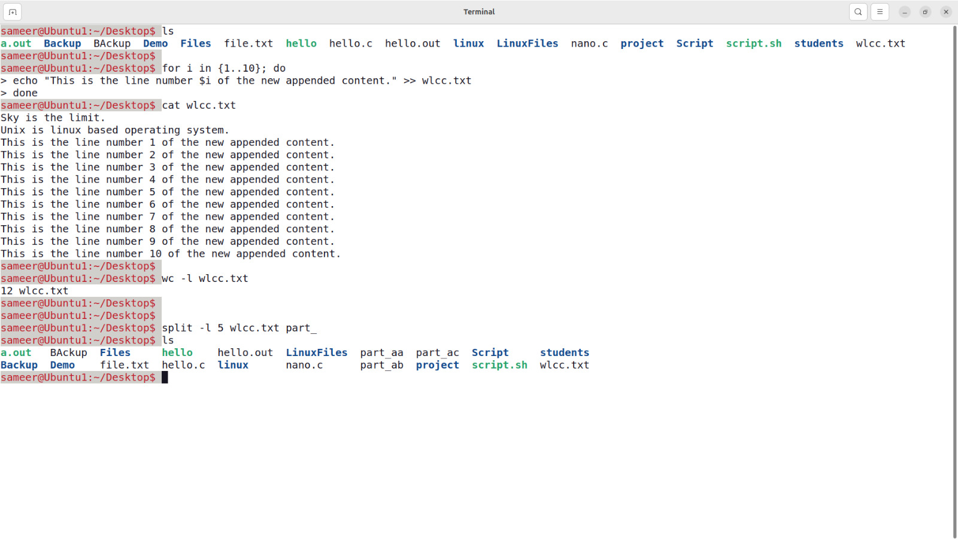

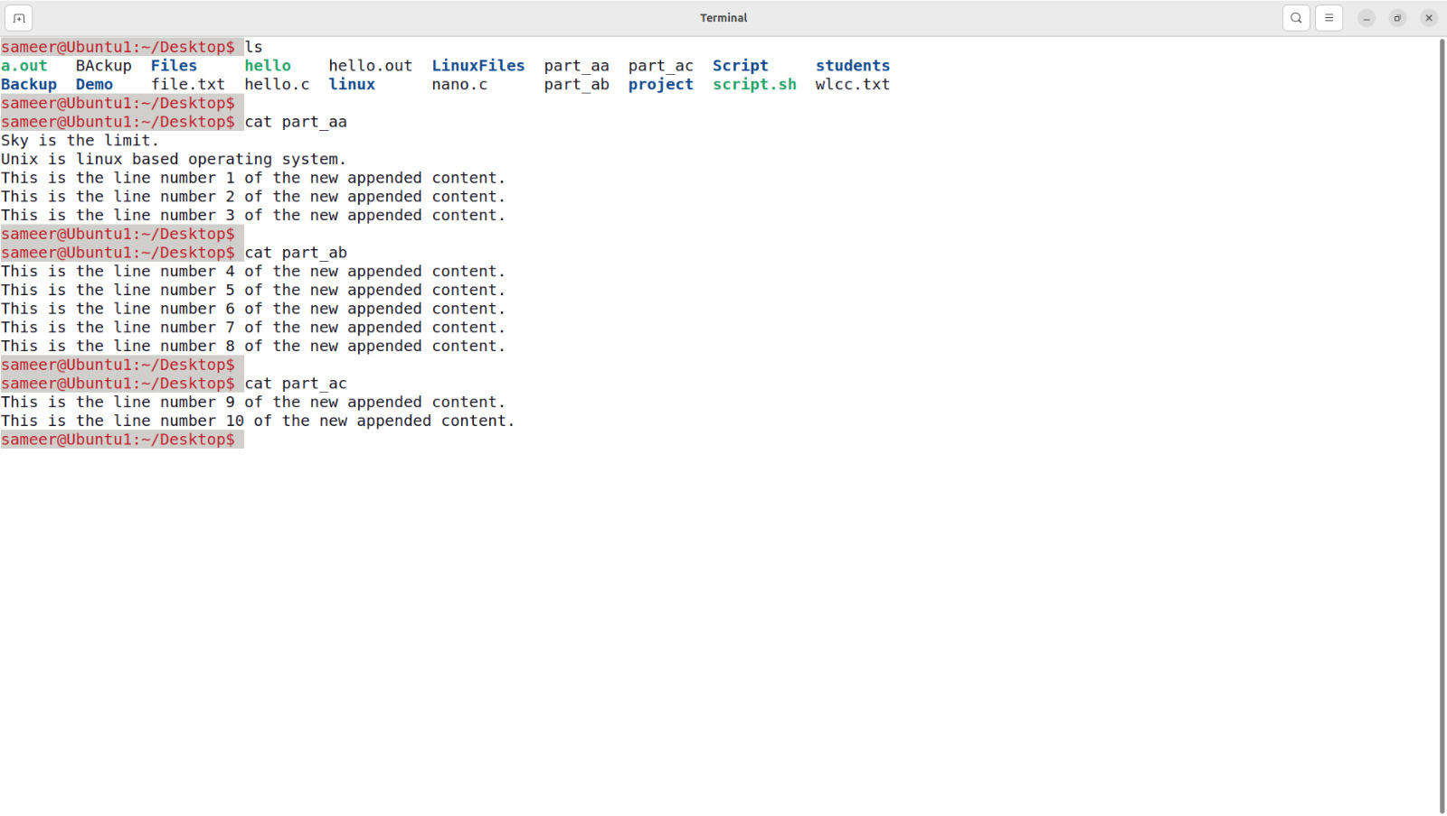

**Q5.** Given two files each of which contains names of students. Create a program to display only those names that are found on both the files.

To find the common names in two files using just commands in the terminal, you can use grep commands in Ubuntu.

To use nano to create and edit files in Ubuntu, follow these steps:

**Step 1: Create the First File (file1.txt) Using nano**

1. Open nano to create file1.txt:

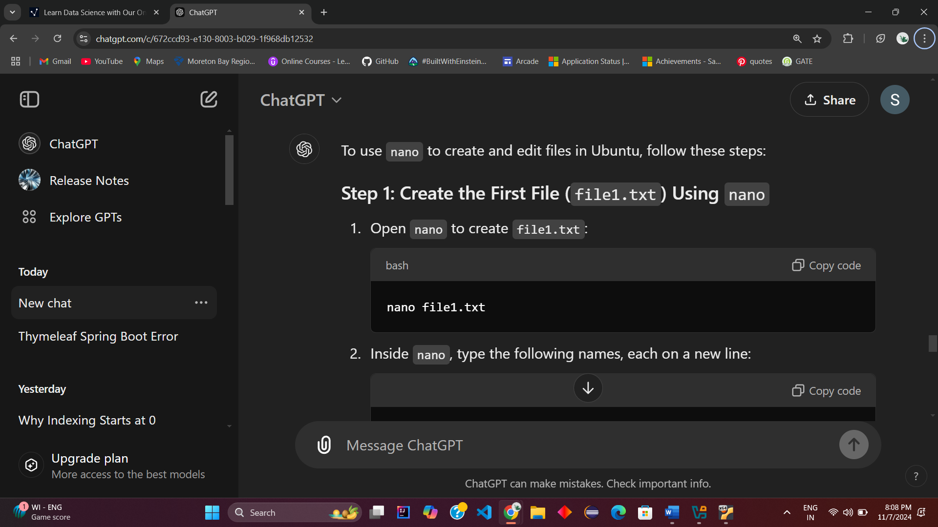

1. Inside nano, type the following names, each on a new line:

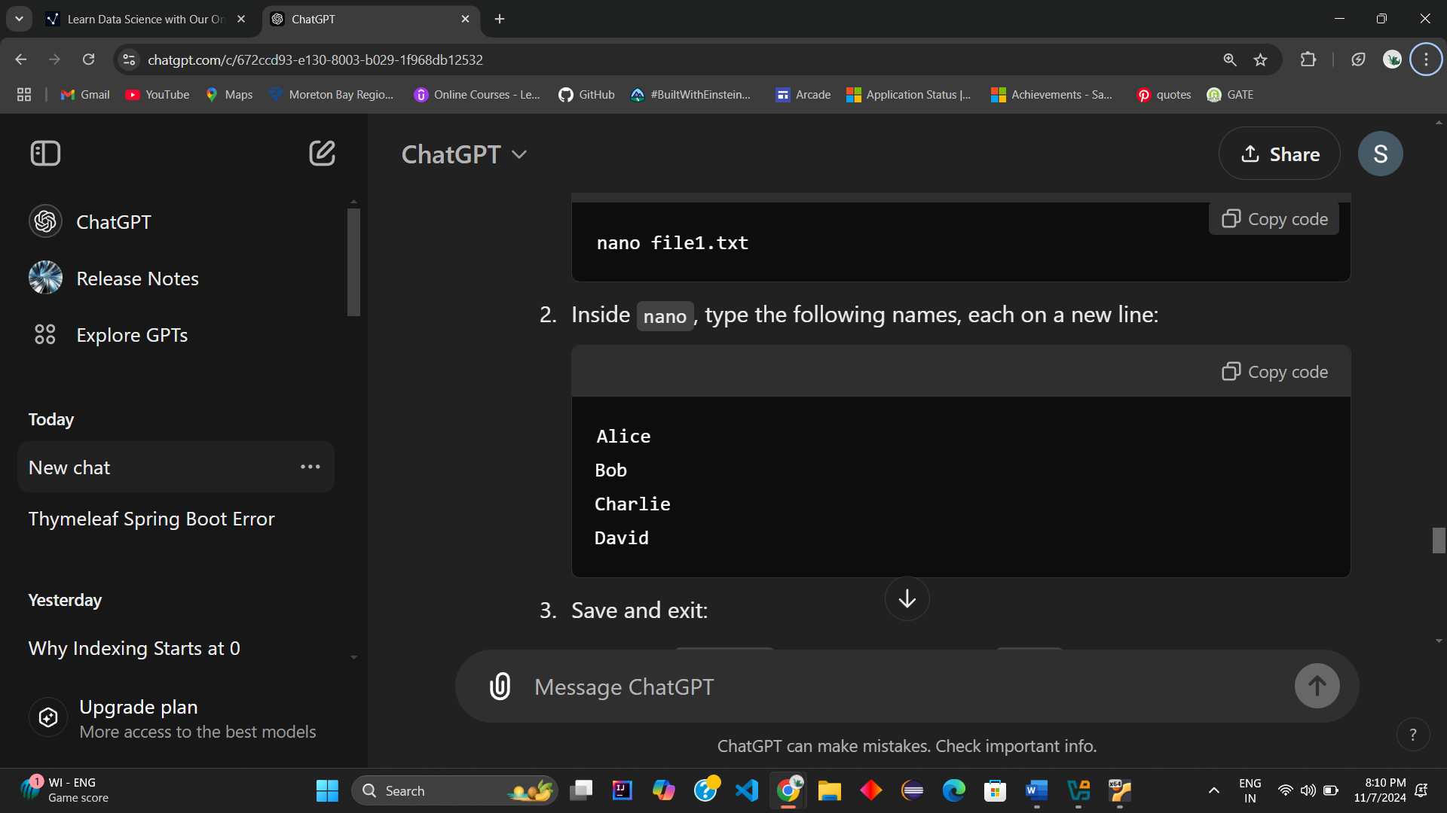

1. Save and exit:

* Press Ctrl + O to save the file. Press Enter to confirm the filename.
* Press Ctrl + X to exit nano.

**Step 2: Create the First File (file2.txt) Using nano**

1. Open nano to create file1.txt:

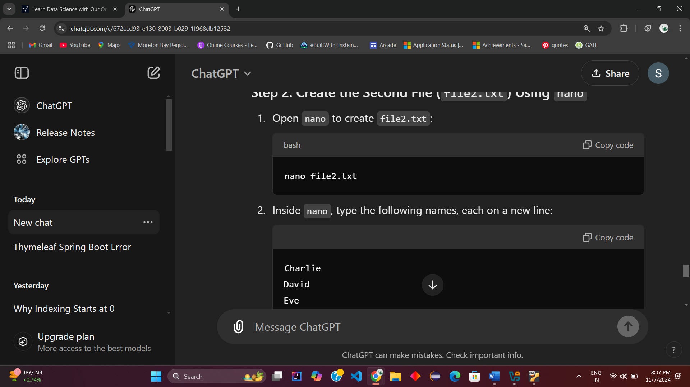

1. Inside nano, type the following names, each on a new line:

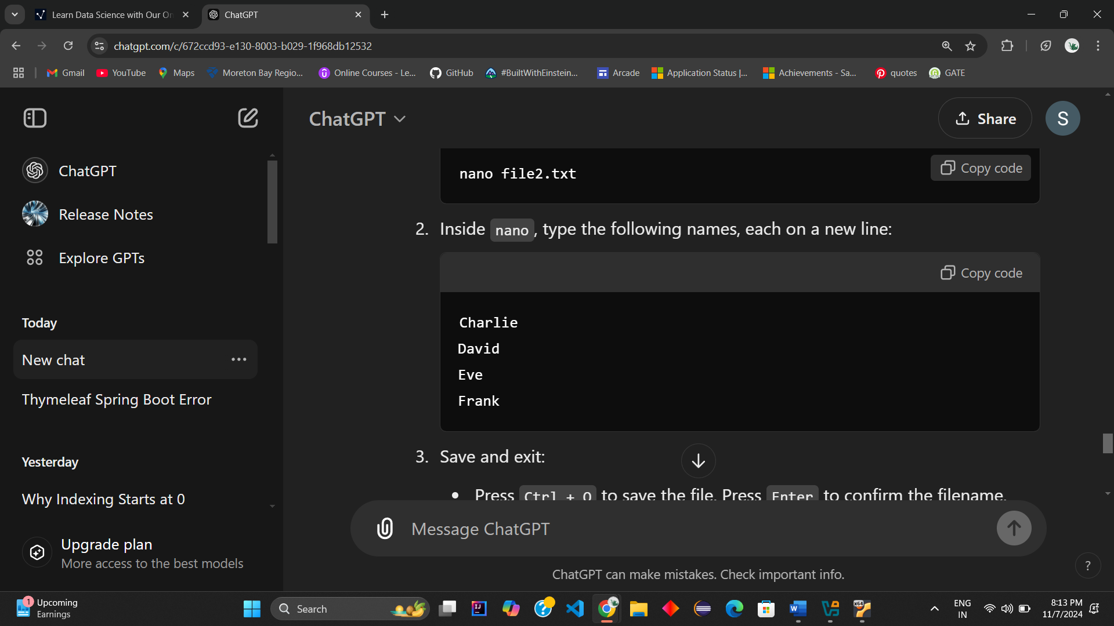

1. Save and exit:

* Press Ctrl + O to save the file. Press Enter to confirm the filename.
* Press Ctrl + X to exit nano.

**Step 3: Sort the contents of each file** (in case they aren’t already sorted):

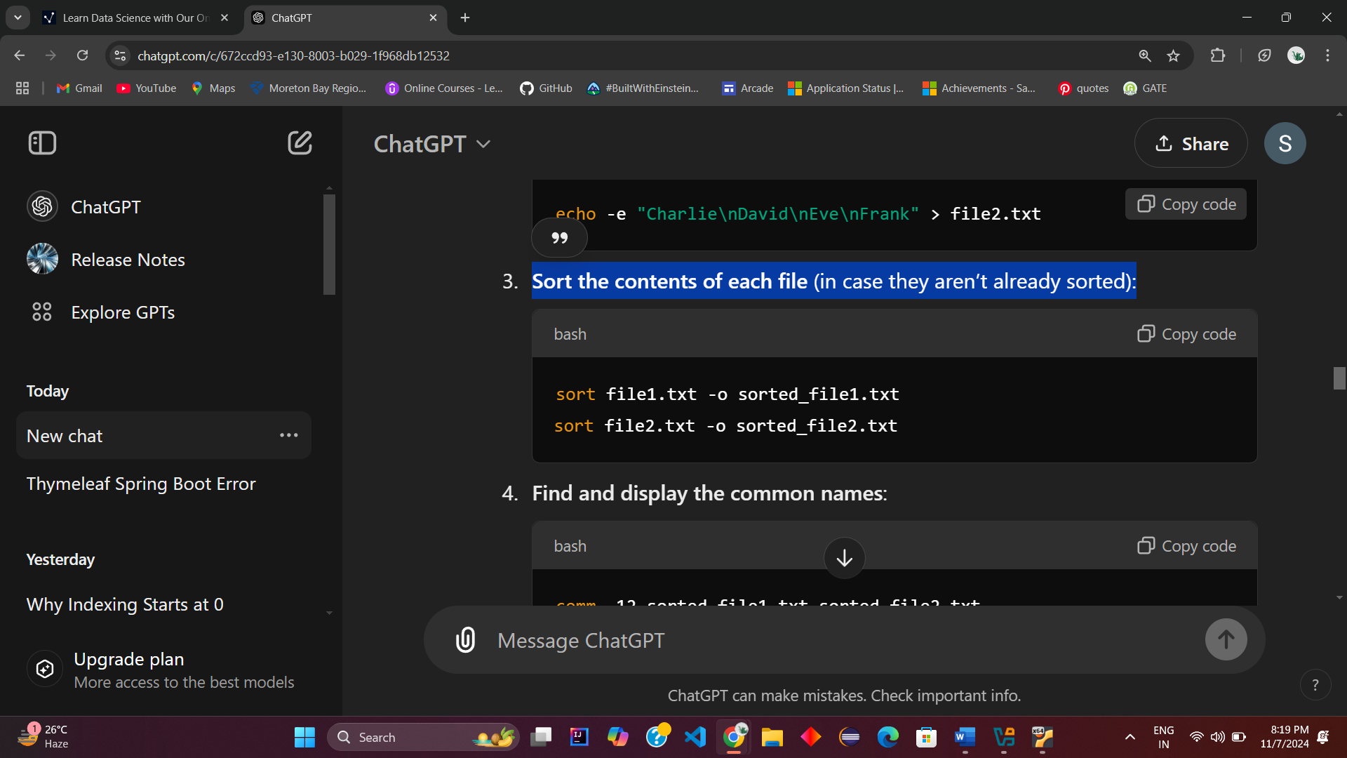

**Step 4: Find and display the common names**:

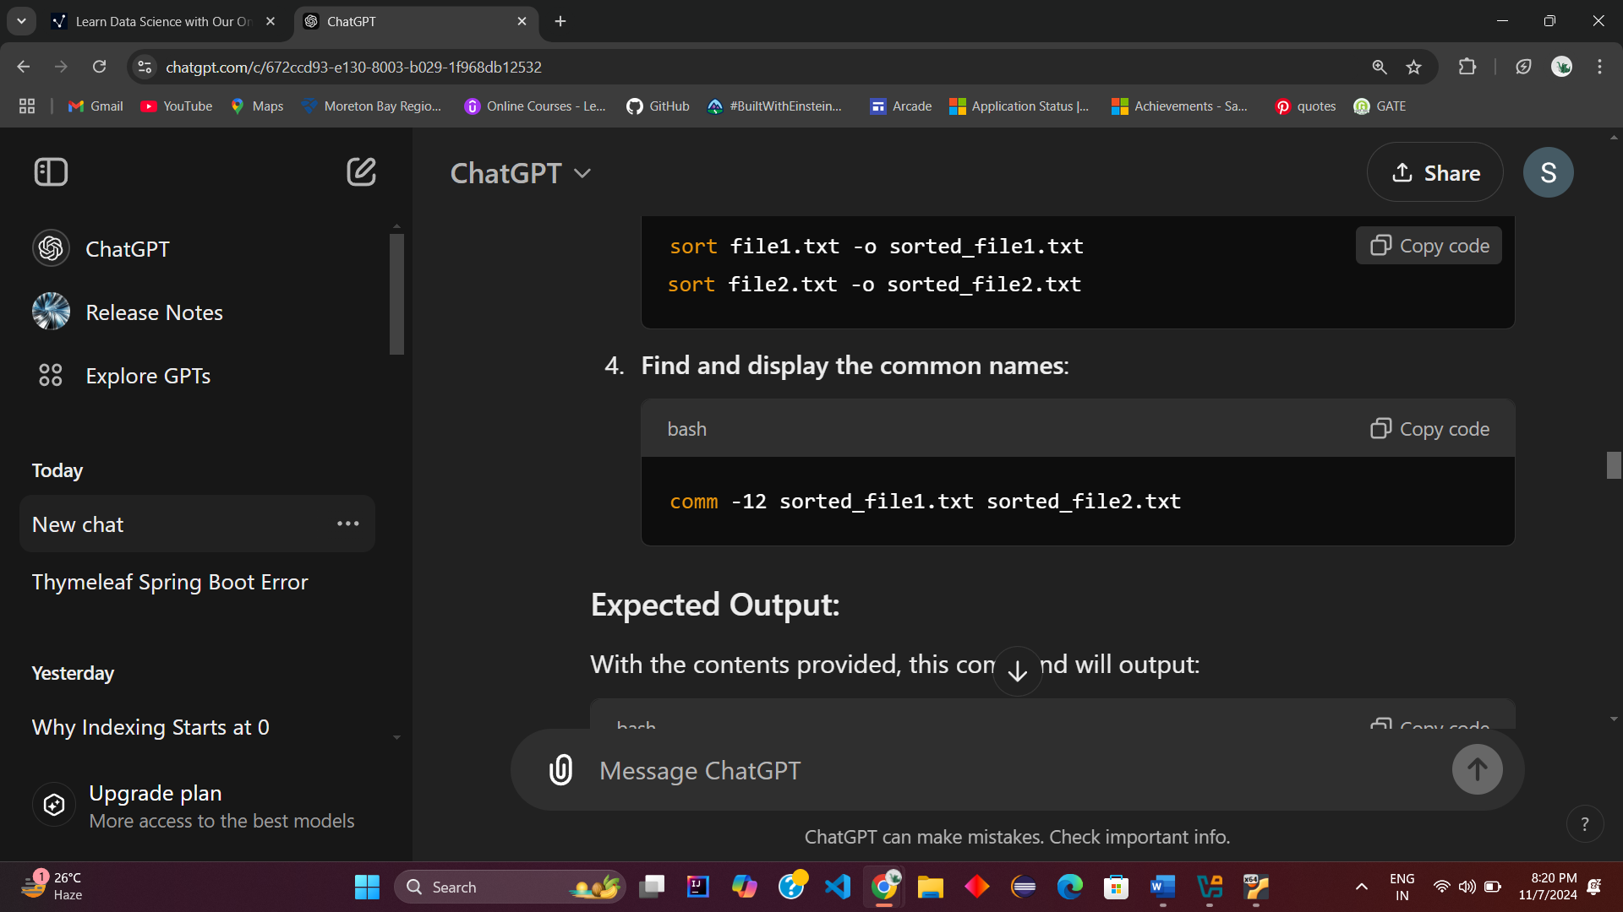

* **-1**: Suppresses lines that are unique to the first file (only the lines that appear in file1.txt but not in file2.txt).
* **-2**: Suppresses lines that are unique to the second file (only the lines that appear in file2.txt but not in file1.txt).
* **Using -12 together**: Suppresses both the first and second columns, leaving only the third column, which contains lines that are common to both files.

**Expected Output**

This command will display:

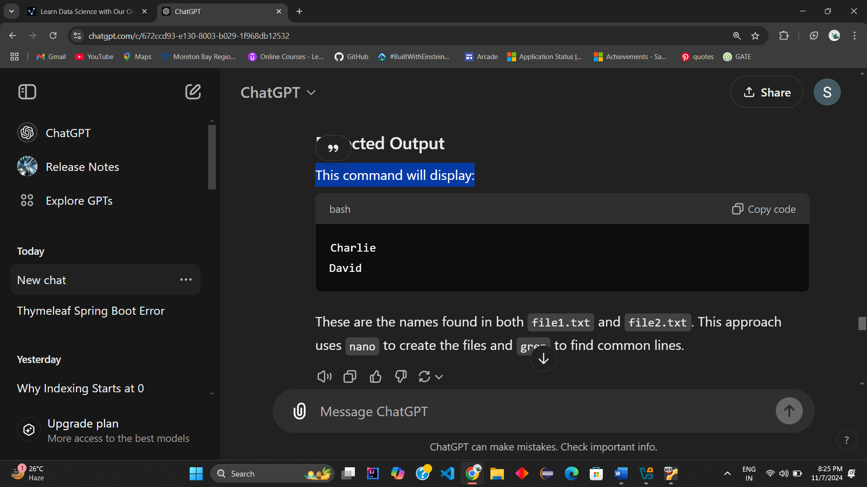

These are the names found in both file1.txt and file2.txt. This approach uses nano to create the files and grep to find common lines.

**Q.6** Create a program to find out the inode number of any file.

To find the inode number of a file in a program, you can use a small shell command in Linux, or write a program in Python that retrieves the inode number. Here are both methods:

**Method 2: Using a Python Program**

Assume we have a file called example.txt in the current directory. Here’s the Python program:

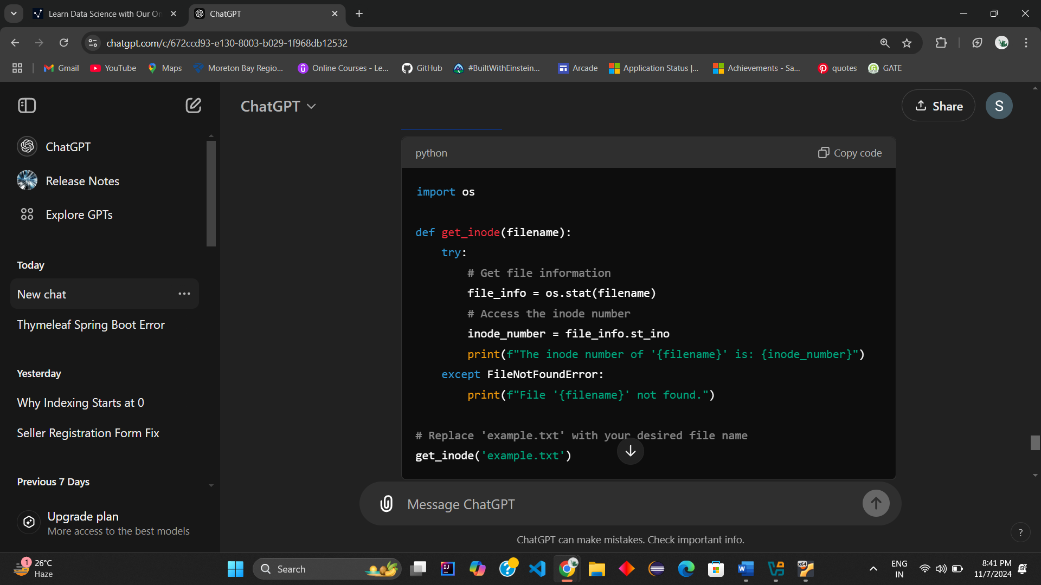

**Running the Program:**

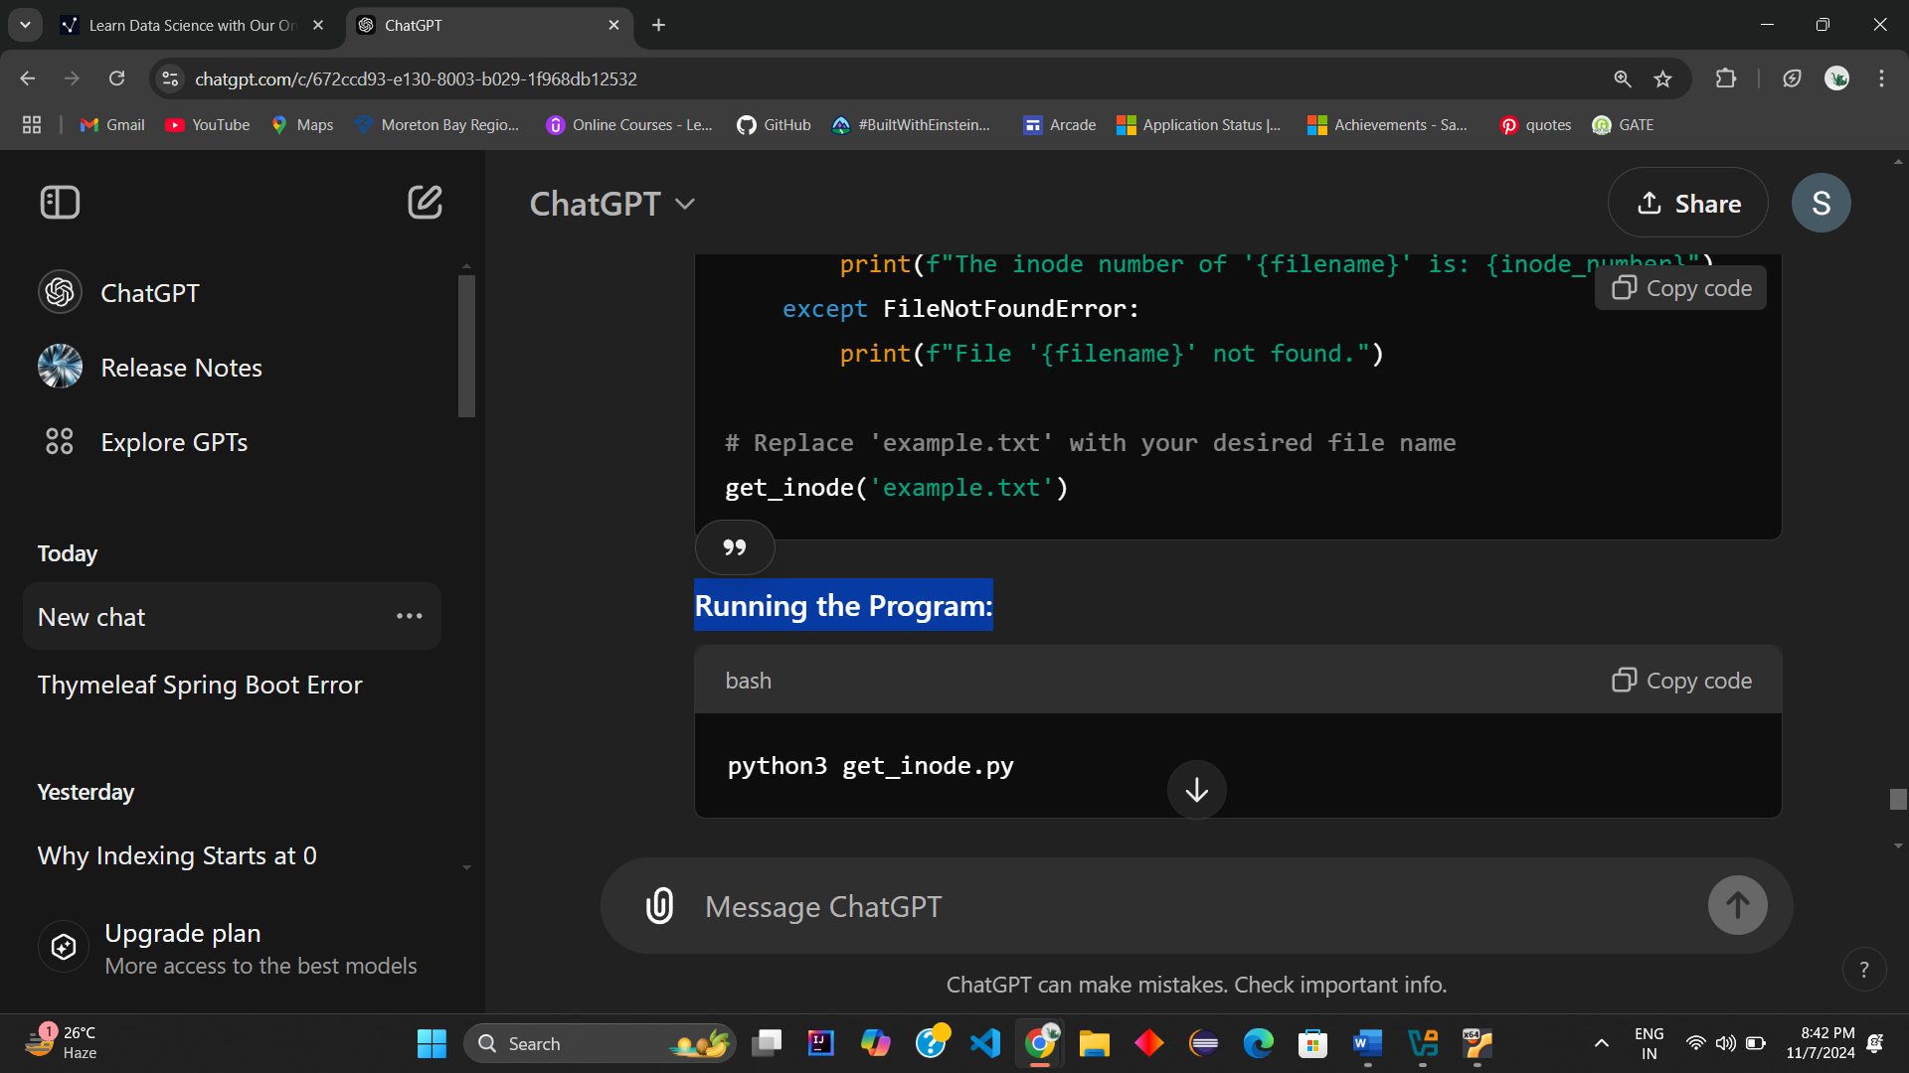

**Sample Output:**

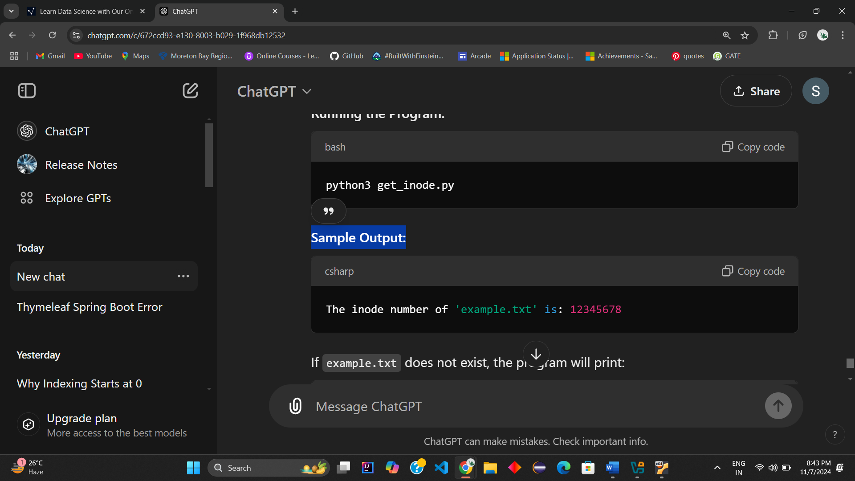

If example.txt does not exist, the program will print:

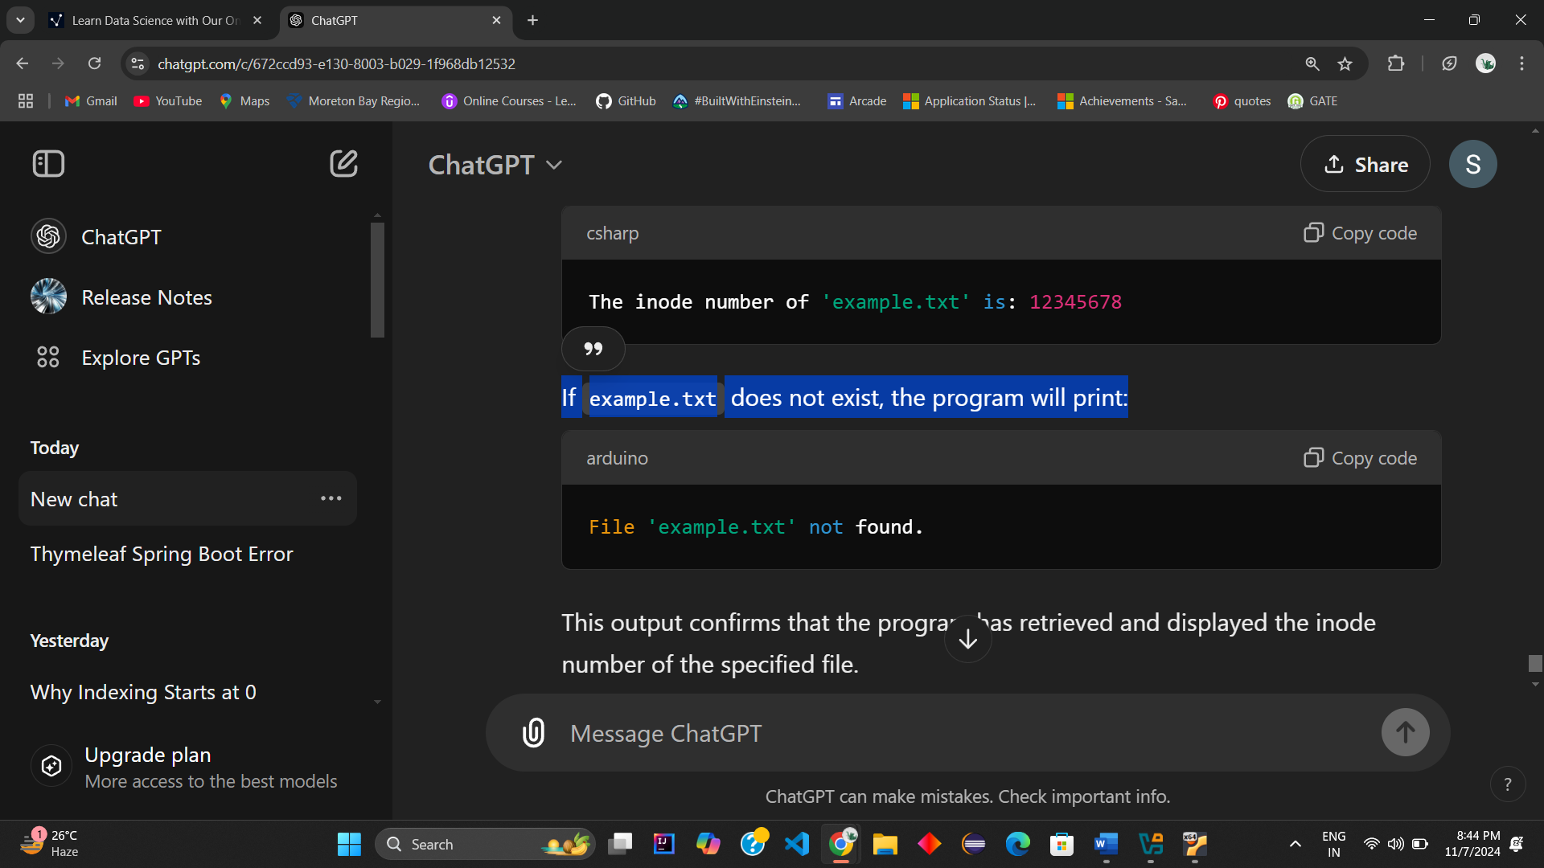

This output confirms that the program has retrieved and displayed the inode number of the specified file.

**Method 2: Using Shell Command (Bash)**

You can use the ls command with the -i option to display the inode number of a file:

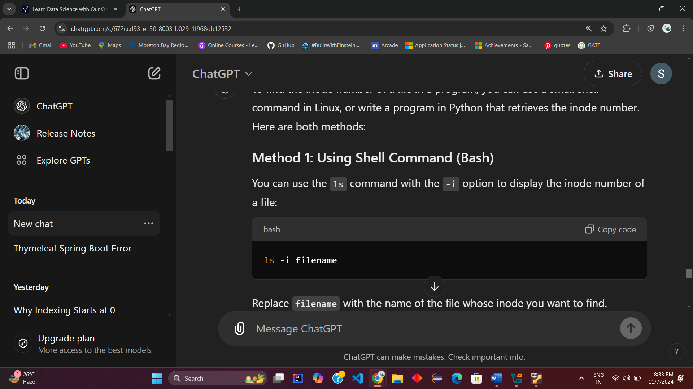

For example:

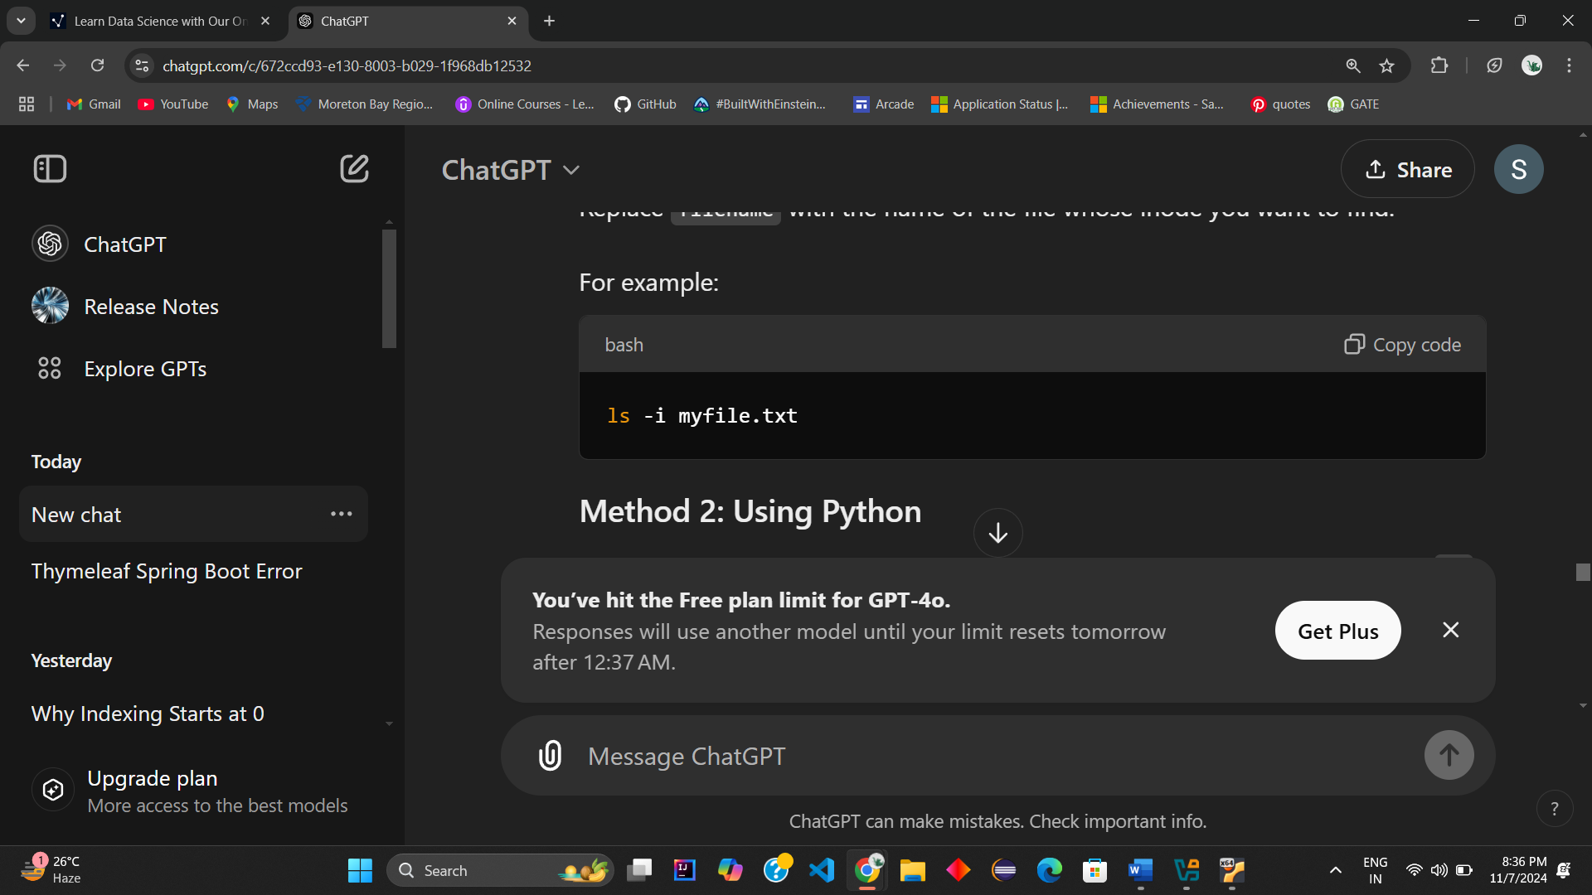

Sample Output:

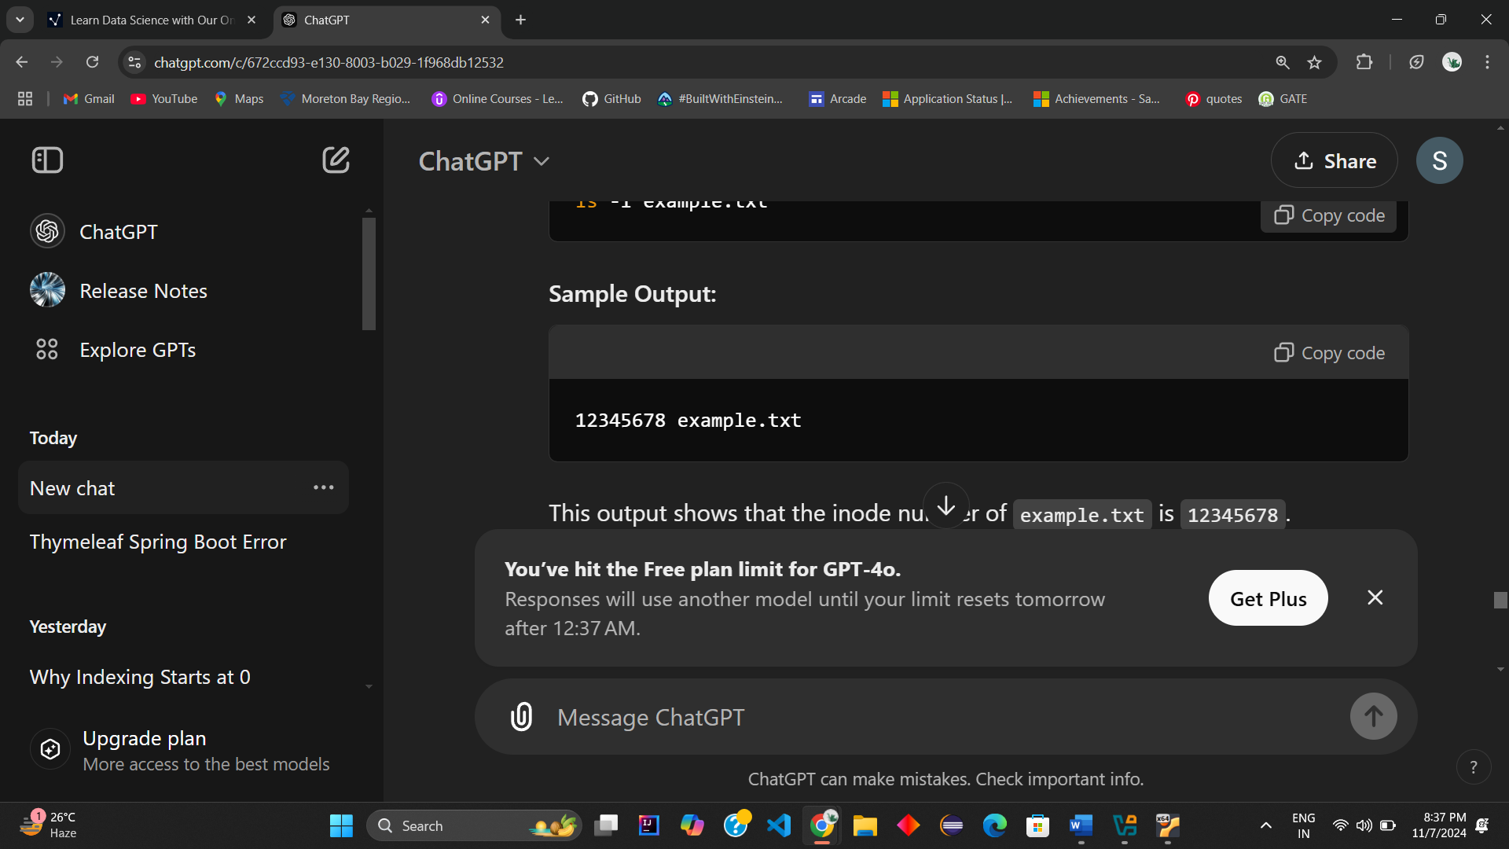

This output shows that the inode number of example.txt is 12345678.

**Q7.** Study & use of the Command for changing file permissions.

In Unix/Linux systems, the command used to change file permissions is chmod. This command allows users to modify the read, write, and execute permissions for files and directories. Here’s a comprehensive study of how to use chmod.

**Understanding File Permissions**

Before diving into the command, it’s important to understand how permissions work:

1. **Types of Permissions**:
   * **Read (r)**: Allows reading the file or listing the directory.
   * **Write (w)**: Allows modifying the file or adding/removing files in the directory.
   * **Execute (x)**: Allows executing the file (if it is a program) or entering the directory.
2. **Permission Structure**: Permissions are displayed as a string of 10 characters:

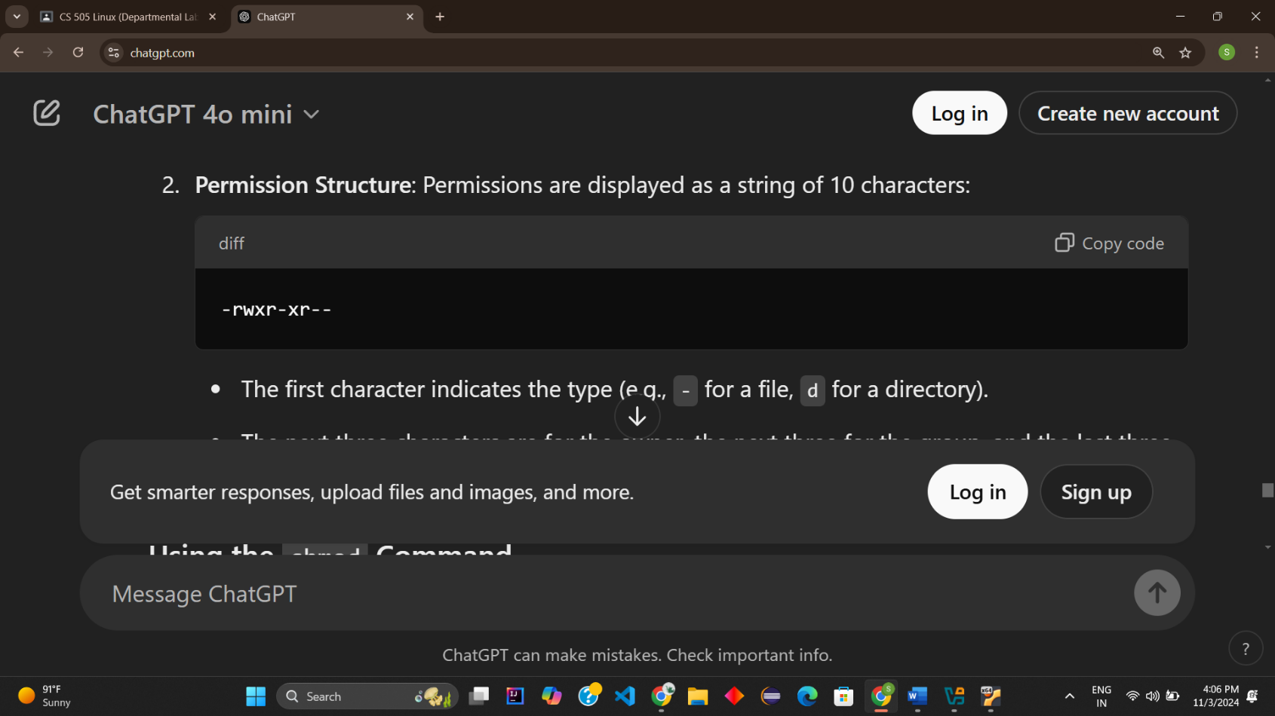

* + The first character indicates the type (e.g., - for a file, d for a directory).
  + The next three characters are for the owner, the next three for the group, and the last three for others.

**Using the chmod Command**

The chmod command can be used in two primary ways: symbolic mode and numeric (octal) mode.

**1. Symbolic Mode**

In symbolic mode, you use letters to specify the permissions you want to add or remove.

* **Syntax**:

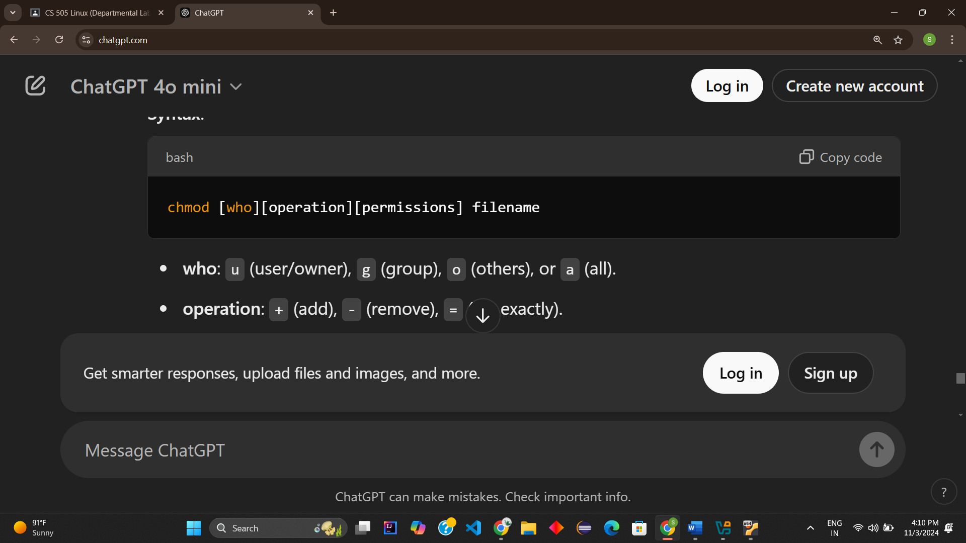

* **who**: u (user/owner), g (group), o (others), or a (all).
* **operation**: + (add), - (remove), = (set exactly).
* **permissions**: r (read), w (write), x (execute).

**Examples**:

* Add execute permission for the user: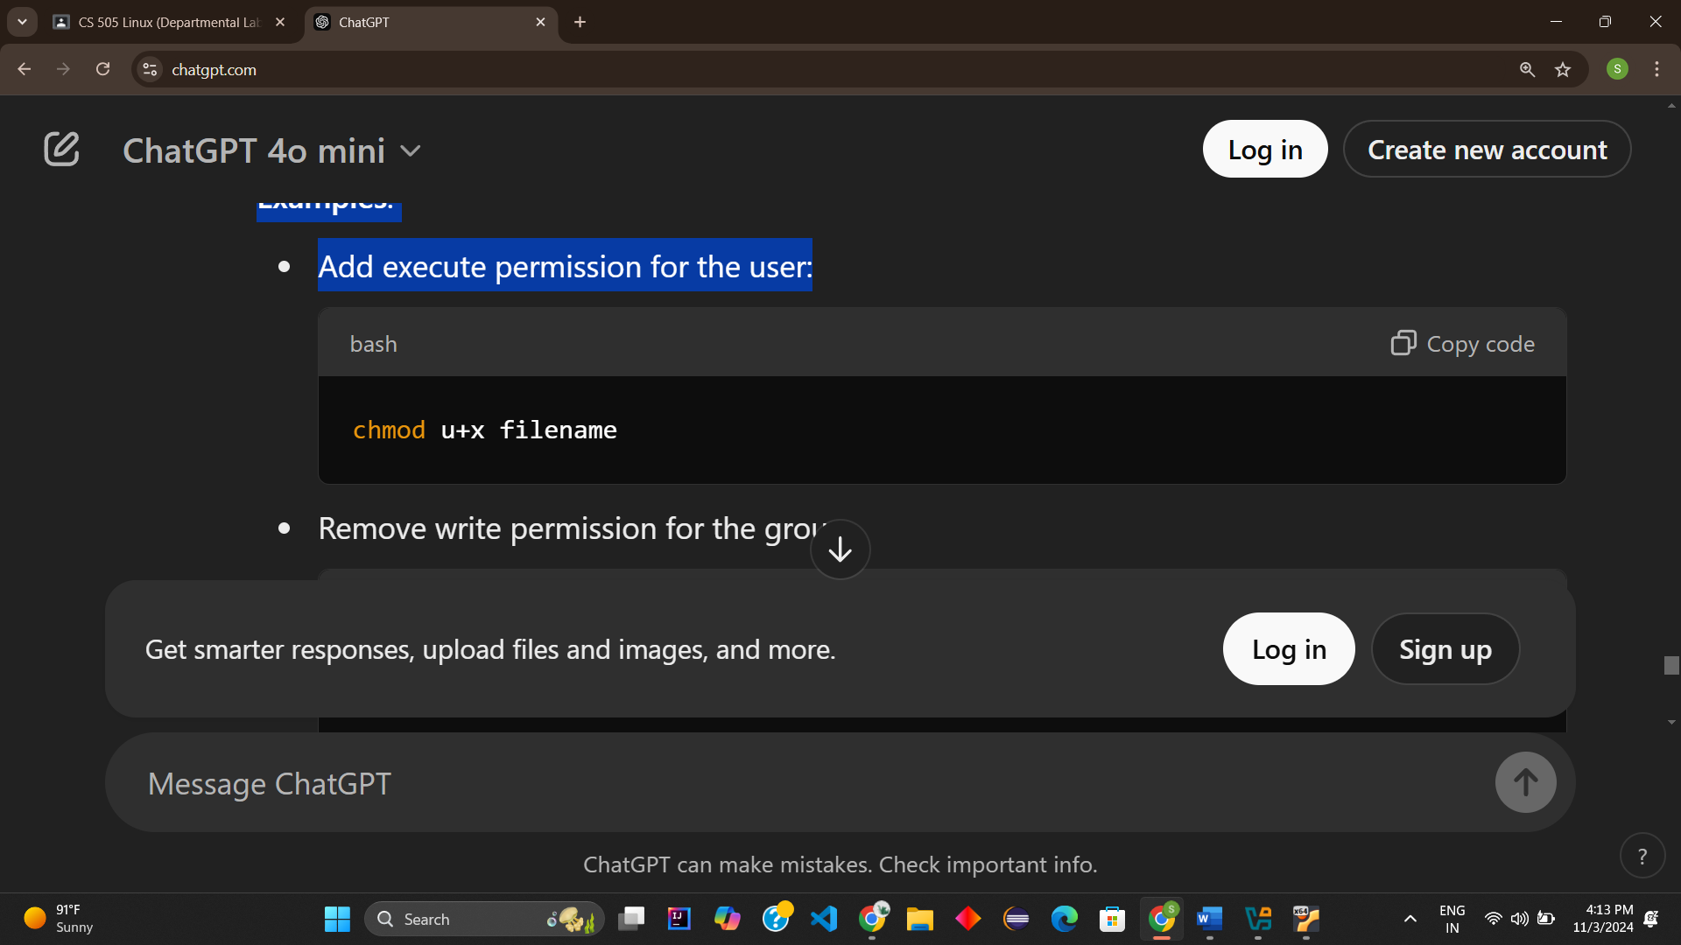
* Remove write permission for the group:

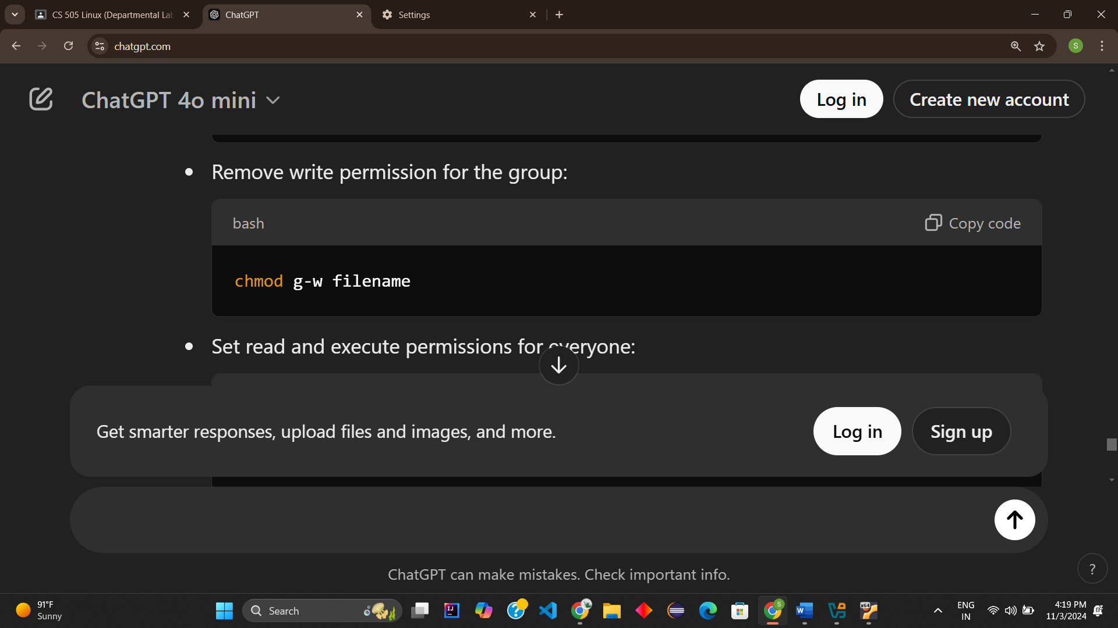

* Set read and execute permissions for everyone:

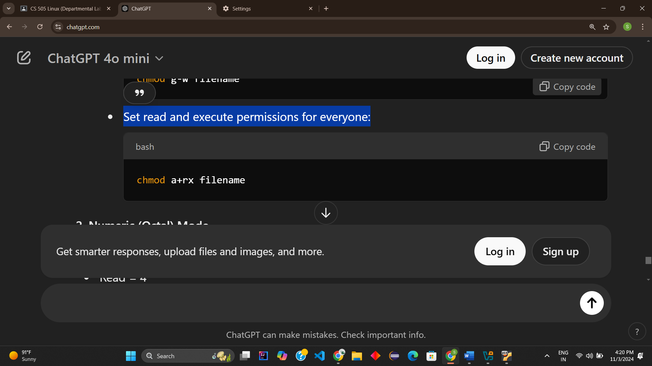

**2. Numeric (Octal) Mode**

In numeric mode, you specify permissions with numbers. Each permission has a corresponding value:

* Read = 4
* Write = 2
* Execute = 1

You add these values together for each user type.

* **Syntax**:

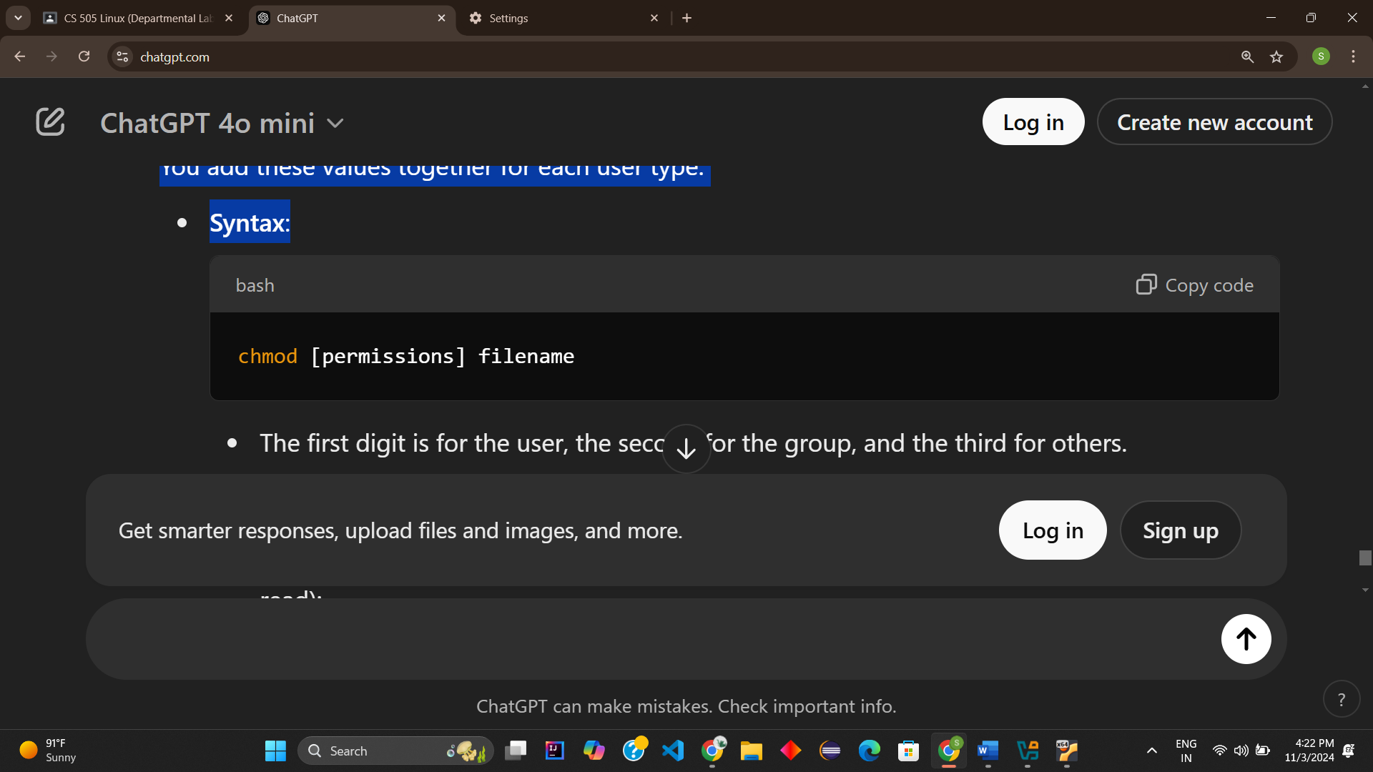

* The first digit is for the user, the second for the group, and the third for others.

**Examples**:

* Set permissions to rwxr-xr-- (Owner: read, write, execute; Group: read, execute; Others: read):

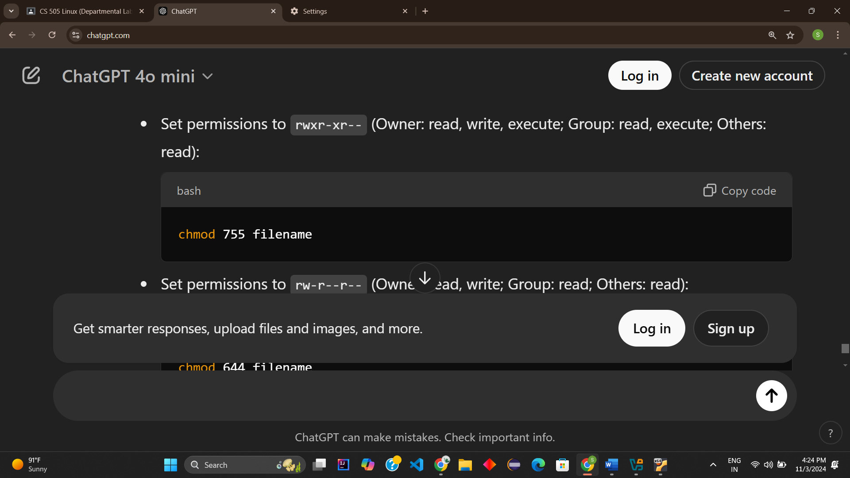

* Set permissions to rw-r--r-- (Owner: read, write; Group: read; Others: read):

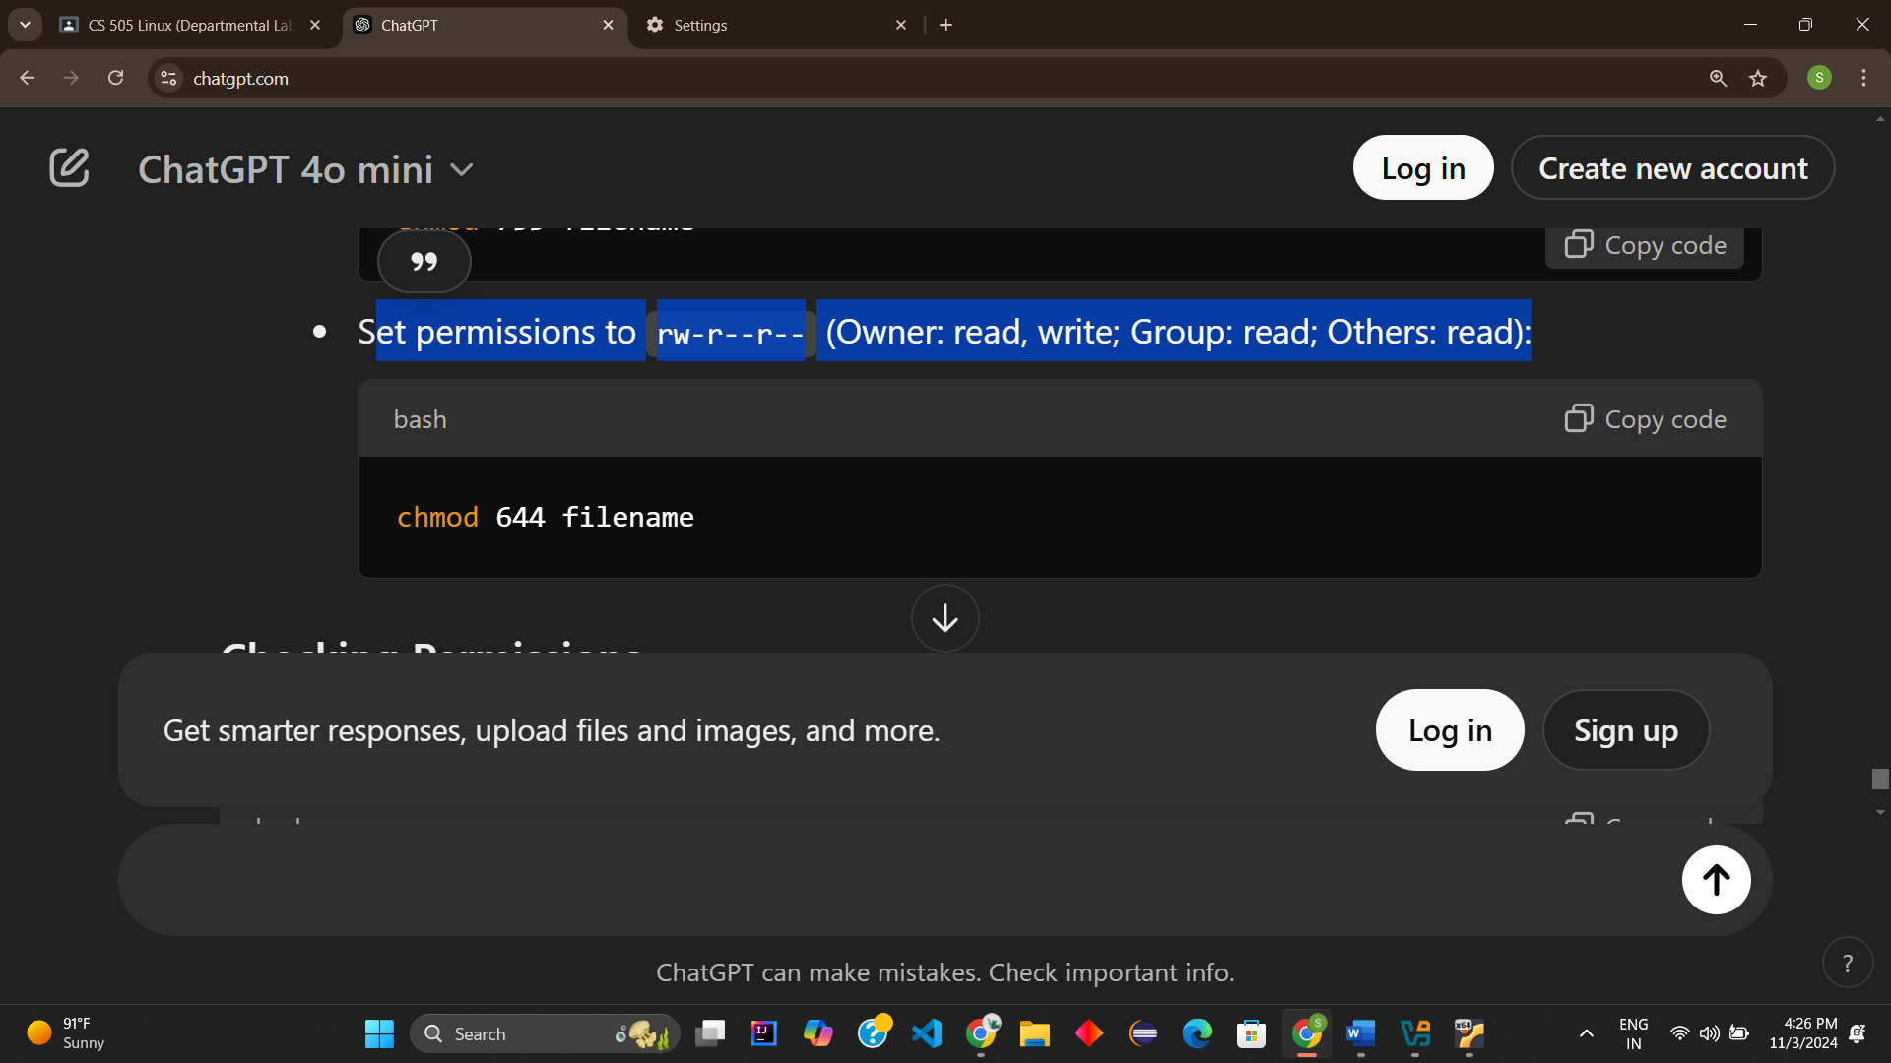

**Checking Permissions**

To check the current permissions of a file or directory, use the ls -l command:

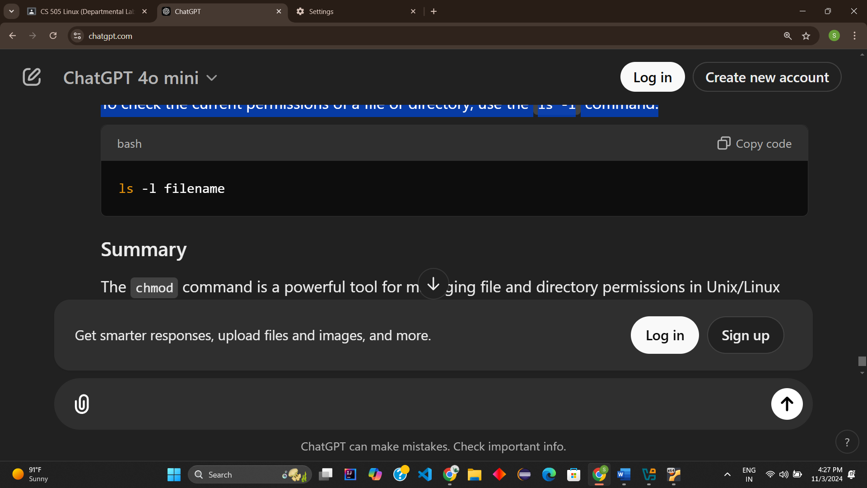

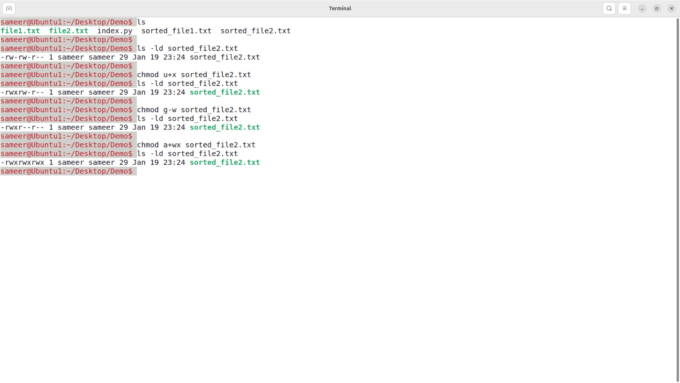

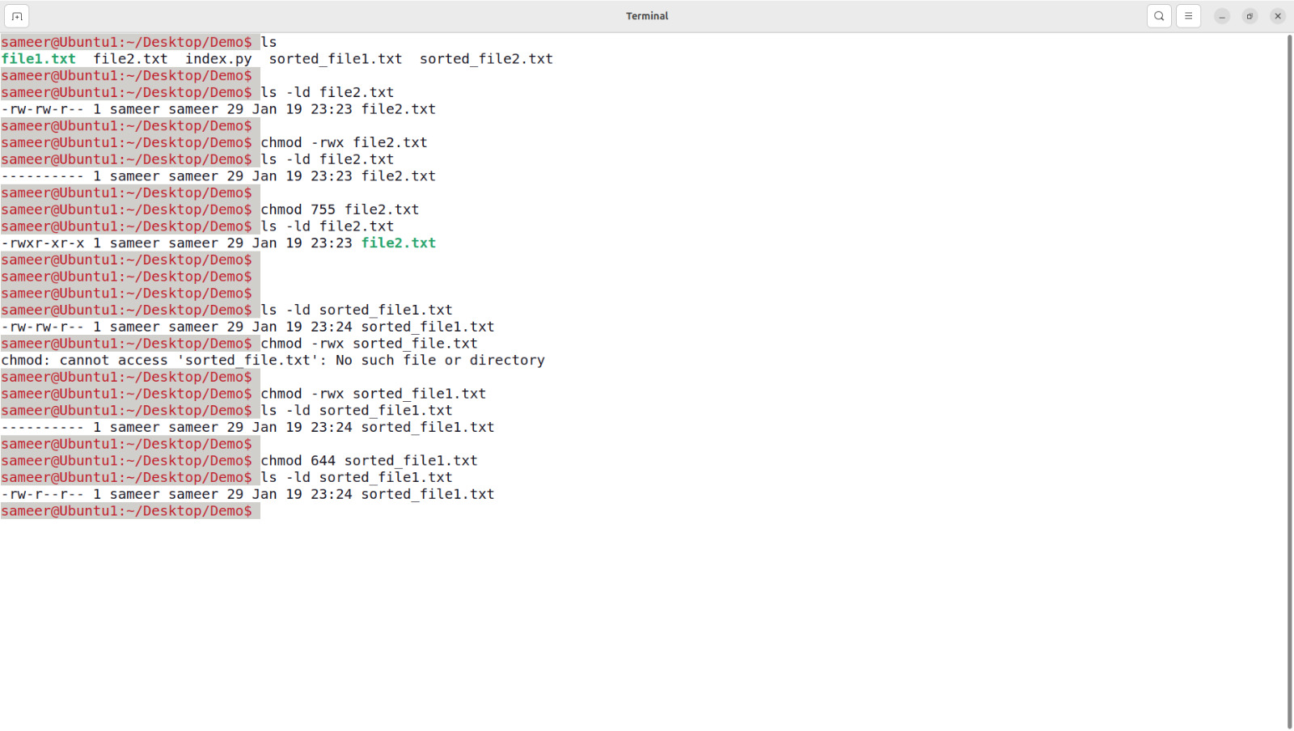

**Q.8** Write a pipeline of commands, which displays on the monitor as well as saves the information about the number of users using the system at present on a file called usere.ux.

**Pipeline of Commands :**

combination of shell commands can be achieved in a pipeline. Here's a command that displays the number of users currently using the system and saves the same information to a file called usere.ux:

who | wc -l | tee usere.ux

**Explanation:**

1. **who**: Lists all logged-in users.
2. **wc -l**: Counts the number of lines in the output of the who command, which corresponds to the number of users.
3. **tee usere.ux**:
   * Displays the output on the terminal.
   * Simultaneously writes the output to the file usere.ux.

This pipeline ensures the number of users is displayed and saved to the file in one step.

**Output:**

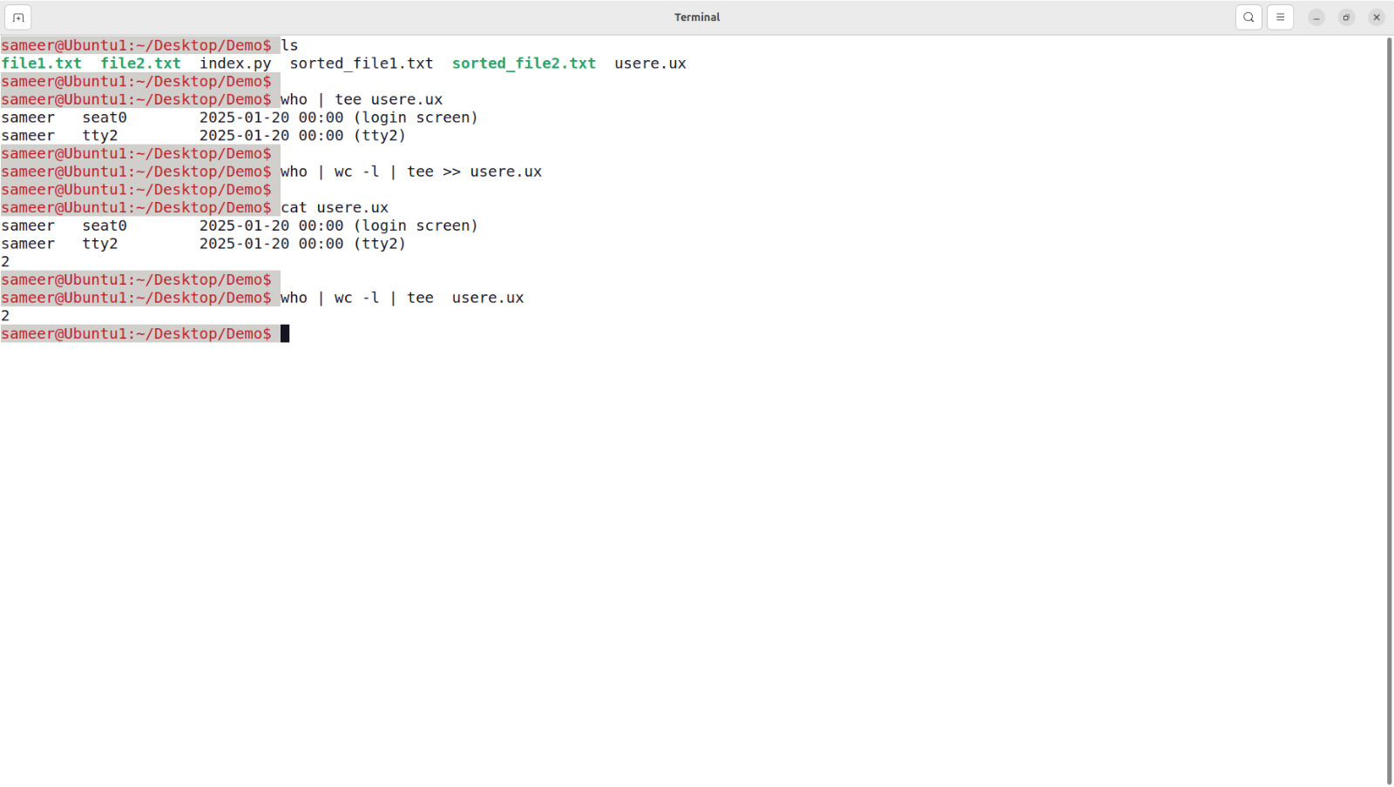

**Q.9** Execute shell commands through vi editor.

To execute shell commands while using the **vi** (or **vim**) editor, you can use the following techniques:

**1. Run a Shell Command Directly**

While in command mode in vi/vim:

* Press : to enter the command mode.
* Type ! followed by the shell command you want to run.
  + Example:

:!ls

* This runs the ls command and displays the output in the editor temporarily. Press **Enter** to return to editing.

**2. Insert Shell Command Output into the File**

To insert the output of a shell command into the file:

* Press : to enter the command mode.
* Type r ! followed by the shell command.
  + Example:

:r !date > filename

* This inserts the current date and time into the file at the current cursor position.

**3. Execute Commands in a Shell from Within vi**

* While in vi/vim, type:

:sh

This temporarily drops you into a shell. You can execute commands as usual.

* To return to vi, type:

exit

**4. Write Shell Command Output to a File**

If you're working in vi and want to run a shell command and save its output into your file:

Type:

:r !who | wc -l > filename

This will execute who | wc -l and insert the output (e.g., the number of logged-in users) into the file.

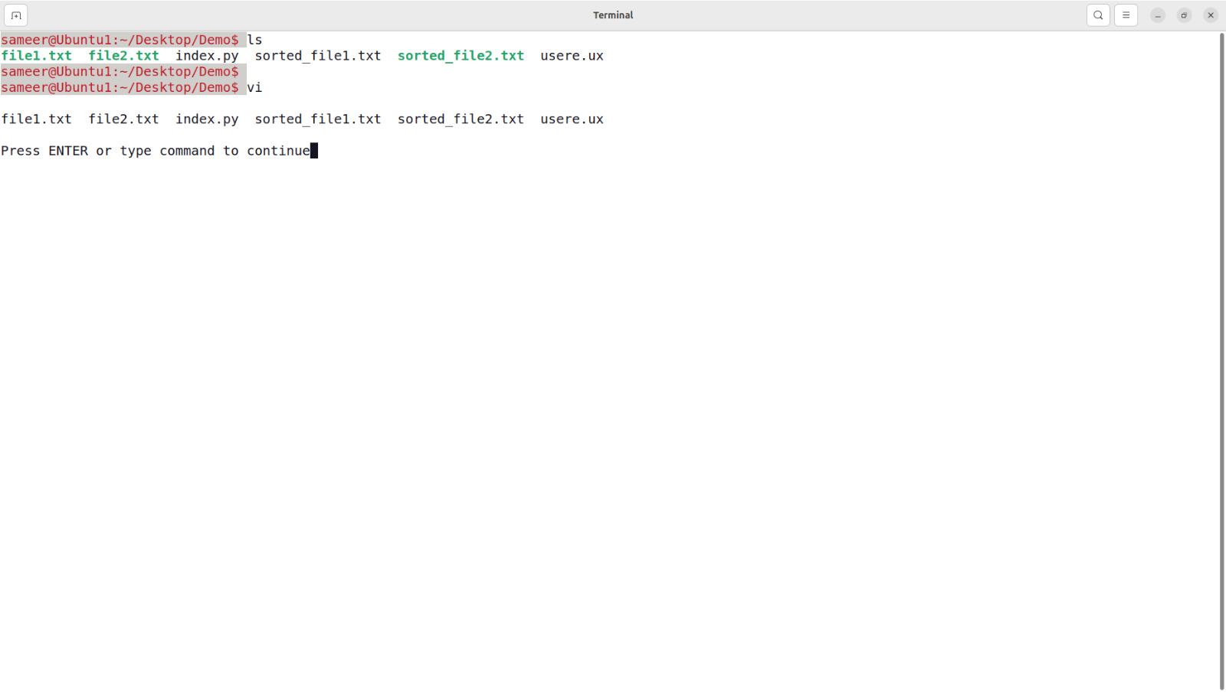

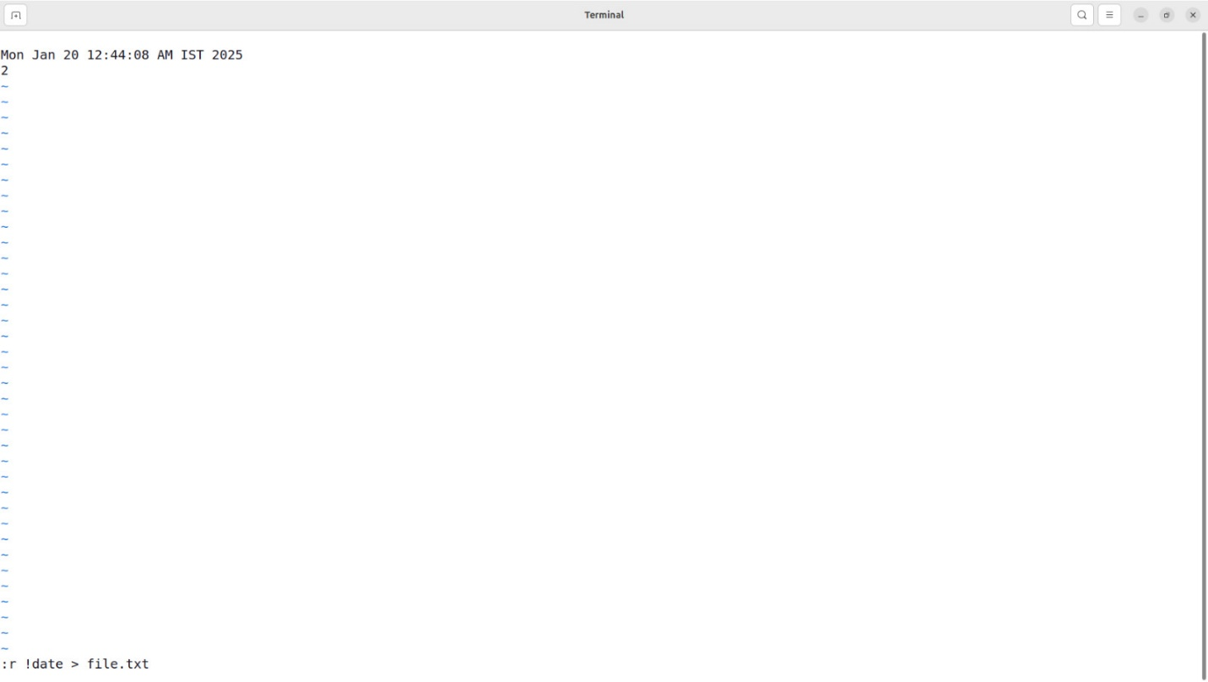

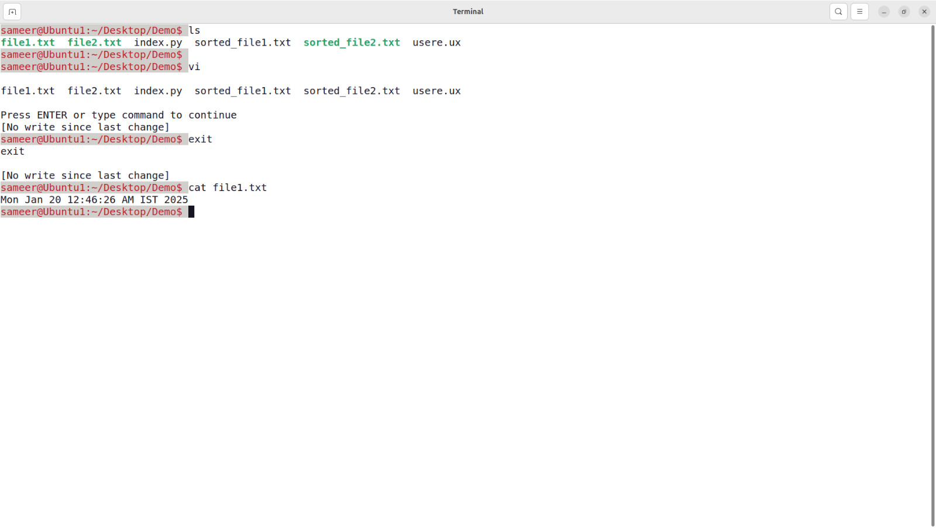

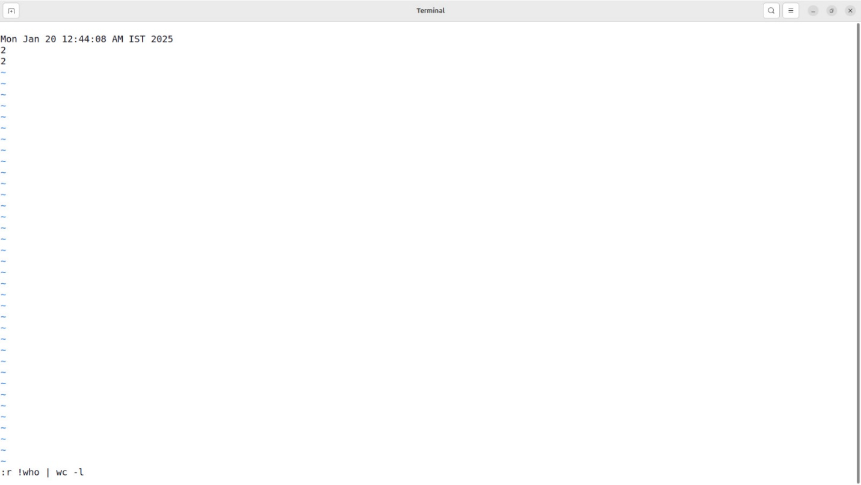

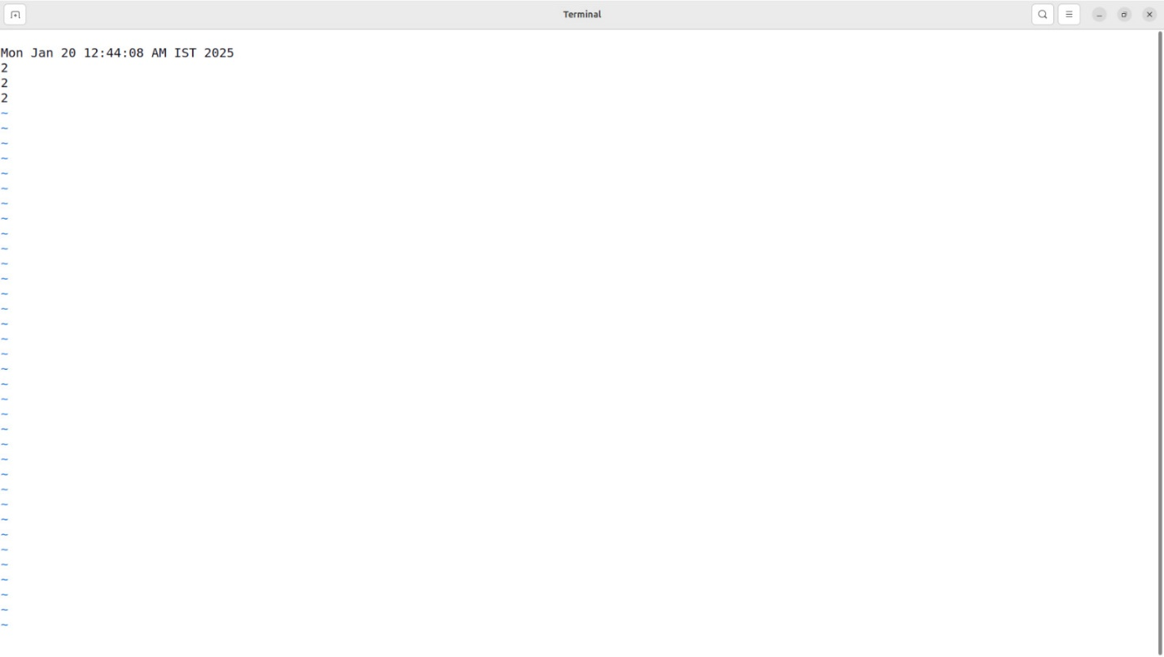

**Q.10** Installation, Configuration &amp; Customizations of Unix/Linux.

**1. Installation of Unix/Linux**

**Prerequisites:**

* A compatible computer or virtual machine.
* A bootable medium (USB/DVD) containing the desired Linux distribution.
* Basic knowledge of disk partitioning and system requirements.

**Steps:**

1. **Choose a Distribution**:
   * Popular Linux distributions include Ubuntu, Fedora, CentOS, Debian, and Red Hat Enterprise Linux.
   * For Unix-based systems, FreeBSD is a common choice.
2. **Download ISO File**:
   * Download the ISO file from the official website of the chosen distribution.
3. **Create a Bootable Medium**:
   * Use tools like **Rufus**, **Etcher**, or **UNetbootin** to create a bootable USB/DVD.
4. **Boot the System**:
   * Insert the bootable medium and boot the system.
   * Select the medium as the boot source from the BIOS/UEFI settings.
5. **Start Installation**:
   * Select "Install" or a similar option from the boot menu.
   * Follow on-screen instructions to configure:
     + Language and region.
     + Disk partitioning (use guided or manual).
     + User account creation (username, password).
     + Additional packages to install.
6. **Finalize Installation**:
   * Complete the setup and reboot the system.
   * Remove the installation medium when prompted.

**2. Configuration of Unix/Linux**

After installation, configure the system to suit your requirements.

**Basic Configuration:**

* **Set Up Network**:
  + Configure networking using tools like nmcli, ifconfig, or ip.
  + Update /etc/network/interfaces or use GUI tools in desktop environments.
* **Update and Upgrade**:

sudo apt update && sudo apt upgrade

* **Install Additional Software**:
  + Use package managers like apt, yum, dnf, or zypper to install required packages.

**Security Configuration:**

**Create User Accounts**:

* + Add new users with:

sudo adduser username

* + Assign appropriate permissions using sudo, chown, and chmod.
* **Secure SSH**:
  + Modify /etc/ssh/sshd_config to disable root login and use SSH keys for authentication.

**3. Customization of Unix/Linux**

Personalize the system to improve productivity and aesthetics.

**Appearance:**

* Change desktop environments or window managers (e.g., GNOME, KDE, XFCE).
* Customize themes and icons using tools like GNOME Tweaks or KDE System Settings.

**Shell Customization:**

* Change the default shell to zsh or fish:

sudo chsh -s /bin/zsh

* Install shell frameworks like **Oh My Zsh** for plugins and themes.

**Startup and Services:**

* Manage startup applications and services using systemctl.  
  Example:

sudo systemctl enable ssh

**Software:**

* Install software tailored to your needs (editors, IDEs, media players). Examples:
  + Editors: vim, nano, or Visual Studio Code.
  + Browsers: firefox, chromium.

**Q.11** Write a shell script that accepts any number of arguments and prints them in the reverse order.

Here's a shell script that accepts any number of arguments and prints them in reverse order:

**Shell Script:**

#!/bin/bash

# Check if arguments are provided

if [ $# -eq 0 ]; then

echo "No arguments provided."

exit 1

fi

# Reverse and print the arguments

echo "Arguments in reverse order:"

for (( i=$#; i>=1; i-- )); do

echo "${!i}"

done

**Explanation:**

1. #!/bin/bash: Specifies that the script should run in the Bash shell.
2. $#: Holds the count of command-line arguments.
3. if [ $# -eq 0 ]: Checks if no arguments are provided.
4. for (( i=$#; i>=1; i-- )): Loops through the arguments in reverse order.
   * $# gives the total number of arguments.
   * ${!i} is used to access the ith argument dynamically.
5. echo "${!i}": Prints each argument in reverse order.

**Example Usage:**

Save the script as reverse_args.sh, and make it executable:

chmod +x reverse_args.sh

**Run the script with some arguments:**

./reverse_args.sh apple banana cherry

**Output :**

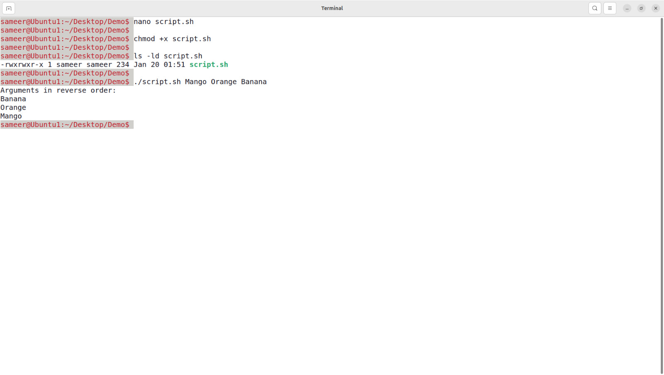

**Q.12** Write a shell script to find the smallest of three numbers that are read from the keyboard.

Here is a shell script that reads three numbers from the keyboard and finds the smallest among them:

**Shell Script:**

#!/bin/bash

# Read three numbers from the user

echo "Enter three numbers:"

read -p "Number 1: " num1

read -p "Number 2: " num2

read -p "Number 3: " num3

# Find the smallest number

if [ "$num1" -le "$num2" ] && [ "$num1" -le "$num3" ]; then

smallest=$num1

elif [ "$num2" -le "$num1" ] && [ "$num2" -le "$num3" ]; then

smallest=$num2

else

smallest=$num3

fi

# Display the result

echo "The smallest number is: $smallest"

**Explanation:**

1. read:
   * Reads three numbers (num1, num2, and num3) from the user input.
2. if and elif:
   * Compares the three numbers using arithmetic comparison operators (-le for "less than or equal to").
3. smallest=$numX:
   * Assigns the smallest number to the variable smallest.
4. echo:
   * Displays the smallest number.

**Example Usage:**

Save the script as smallest_number.sh, and make it executable:

chmod +x smallest_number.sh

Run the script:

./smallest_number.sh

**Sample Input:**

Enter three numbers:

Number 1: 45

Number 2: 12

Number 3: 78

**Output:**

The smallest number is: 12

**Output:**

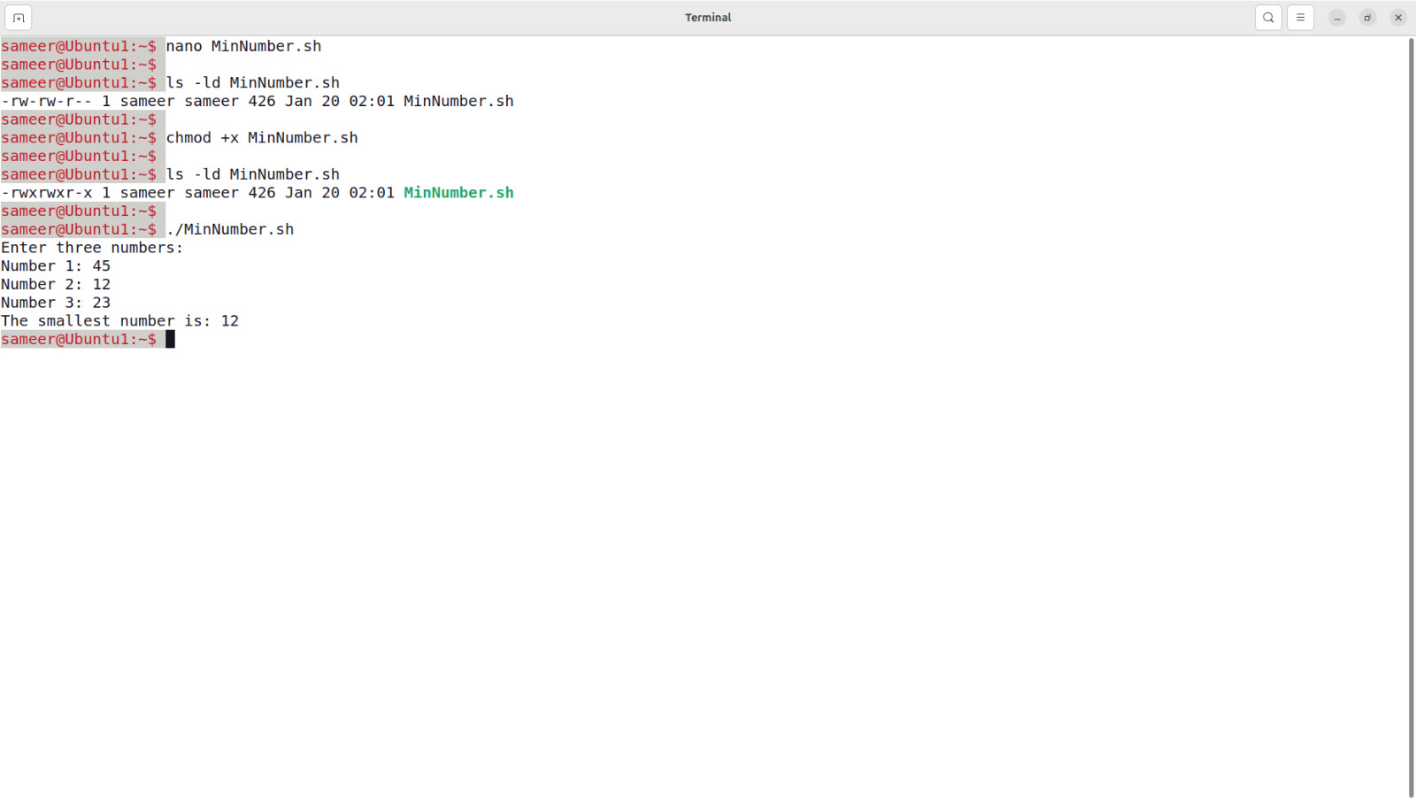

**Q.13** Write a shell script that reports the logging in of a specified user within one minute after he/she logs in. The script automatically terminates if the specified user does not login during a specified period of time.

Here is a shell script to monitor if a specified user logs in within a specified period (e.g., one minute). If the user logs in, the script reports it; otherwise, it terminates automatically after the specified time.

**Shell Script**

#!/bin/bash

# Check if the script is run with a username and timeout period

if [ $# -ne 2 ]; then

echo "Usage: $0 <username> <timeout_in_seconds>"

exit 1

fi

# Get the username and timeout period from arguments

username=$1

timeout=$2

start_time=$(date +%s)

echo "Monitoring login for user: $username"

echo "Timeout period: $timeout seconds"

# Monitor for user login

while true; do

# Check if the user is logged in

if who | grep -q "^$username "; then

echo "User '$username' has logged in!"

exit 0

fi

# Check if the timeout period has elapsed

current_time=$(date +%s)

elapsed_time=$((current_time - start_time))

if [ $elapsed_time -ge $timeout ]; then

echo "Timeout reached. User '$username' did not log in."

exit 1

fi

# Sleep for a short interval before checking again

sleep 2

done

**Explanation**

1. **Arguments Check**:
   * Ensures the script is run with exactly two arguments: the username and the timeout period.
2. **User Monitoring**:
   * Continuously monitors logged-in users using the who command.
   * Uses grep to search for the specified username in the logged-in user list.
3. **Timeout Handling**:
   * Tracks elapsed time using date +%s to get the current timestamp.
   * Compares the elapsed time with the specified timeout period.
4. **Sleep Interval**:
   * Adds a short sleep (2 seconds) between checks to reduce CPU usage.

**Usage**

Save the script as monitor_login.sh and make it executable:

chmod +x monitor_login.sh

Run the script with a username and timeout period:

./monitor_login.sh username 60

**Example :**

**Command**:

./monitor_login.sh john 60

**Output (if the user logs in within 60 seconds)**:

Monitoring login for user: john

Timeout period: 60 seconds

User 'john' has logged in!

**Output (if the timeout period elapses)**:

Monitoring login for user: john

Timeout period: 60 seconds

Timeout reached. User 'john' did not log in.

**Output:**

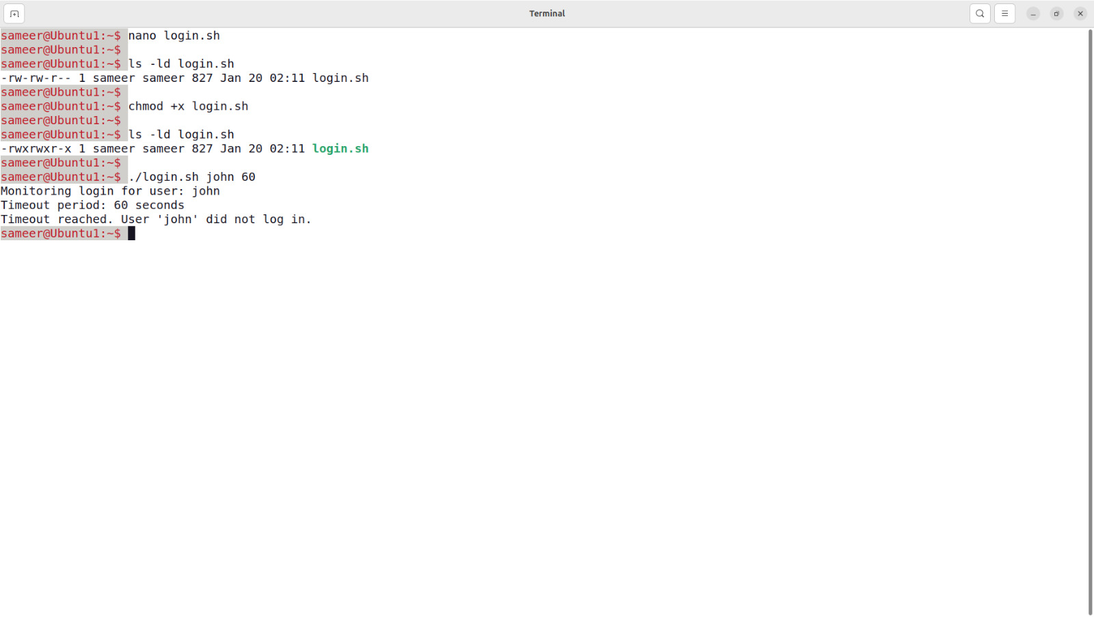

**Q.14 Installation of SAMBA, APACHE, TOMCAT.**

**1. Samba**

* **Purpose**: Samba is an open-source software suite that enables file and printer sharing between Unix/Linux systems and Windows machines using the SMB (Server Message Block) protocol.
* **Use Case**: It allows Linux/Unix servers to appear as Windows file and print servers on a network, making cross-platform resource sharing seamless.

**Samba Installation**

**Step 1: Install Samba**

sudo apt update

sudo apt install samba -y # For Debian/Ubuntu-based systems

**Step 2: Configure Samba**

1. **Edit the Samba configuration file**:

sudo nano /etc/samba/smb.conf

1. Add a shared directory configuration, e.g.:

[shared]

path = /srv/samba/shared

browseable = yes

writable = yes

guest ok = yes

read only = no

1. **Create the shared directory**:

sudo mkdir -p /srv/samba/shared

sudo chmod -R 0777 /srv/samba/shared

**Step 3: Restart Samba Service**

sudo systemctl restart smbd

sudo systemctl enable smbd

**Step 4: Test Samba**

* Check samba status

sudo systemctl status smbd

* Verify the configuration:

Testparm

**2. Apache**

* **Purpose**: Apache HTTP Server is an open-source web server software designed to deliver web pages and applications over the internet.
* **Use Case**: It is widely used for hosting websites and web applications, supporting various programming languages and modules.

**Apache Installation**

**Step 1: Install Apache**

For Debian/Ubuntu-based systems:

sudo apt update

sudo apt install apache2 -y

**Step 2: Start and Enable Apache**

sudo systemctl start apache2 # Use `httpd` for Red Hat-based systems

sudo systemctl enable apache2

**Step 3: Test Apache**

1. Open a browser and go to http://<your_server_IP> or http://localhost.
2. You should see the default Apache page.

**3. Tomcat**

* **Purpose**: Apache Tomcat is an open-source Java Servlet Container that implements Java Servlet, JavaServer Pages (JSP), and other Java web technologies.
* **Use Case**: It is commonly used for deploying Java-based web applications and dynamic websites.

**Tomcat Installation**

**Step 1: Download Tomcat**

1. Visit the official Apache Tomcat website: [Tomcat Downloads](https://tomcat.apache.org/download-10.cgi).
2. Download the latest version or use wget to fetch the binary:

**Step 2: Extract and Move**

tar -xvzf apache-tomcat-10.1.8.tar.gz

sudo mv apache-tomcat-10.1.8 /usr/local/tomcat

**Step 3: Configure Environment Variables**

1. Open the environment configuration file:

sudo nano /etc/environment

1. Add the following lines:

CATALINA_HOME=/usr/local/tomcat

PATH=$PATH:$CATALINA_HOME/bin

1. Load the environment variables:

source /etc/environment

**Step 4: Start Tomcat**

1. Navigate to the Tomcat directory:

cd /usr/local/tomcat/bin

1. Start the Tomcat server:

./startup.sh

**Step 5: Test Tomcat**

1. Open a browser and go to http://<your_server_IP>:8080 or http://localhost:8080.
2. You should see the Tomcat welcome page.

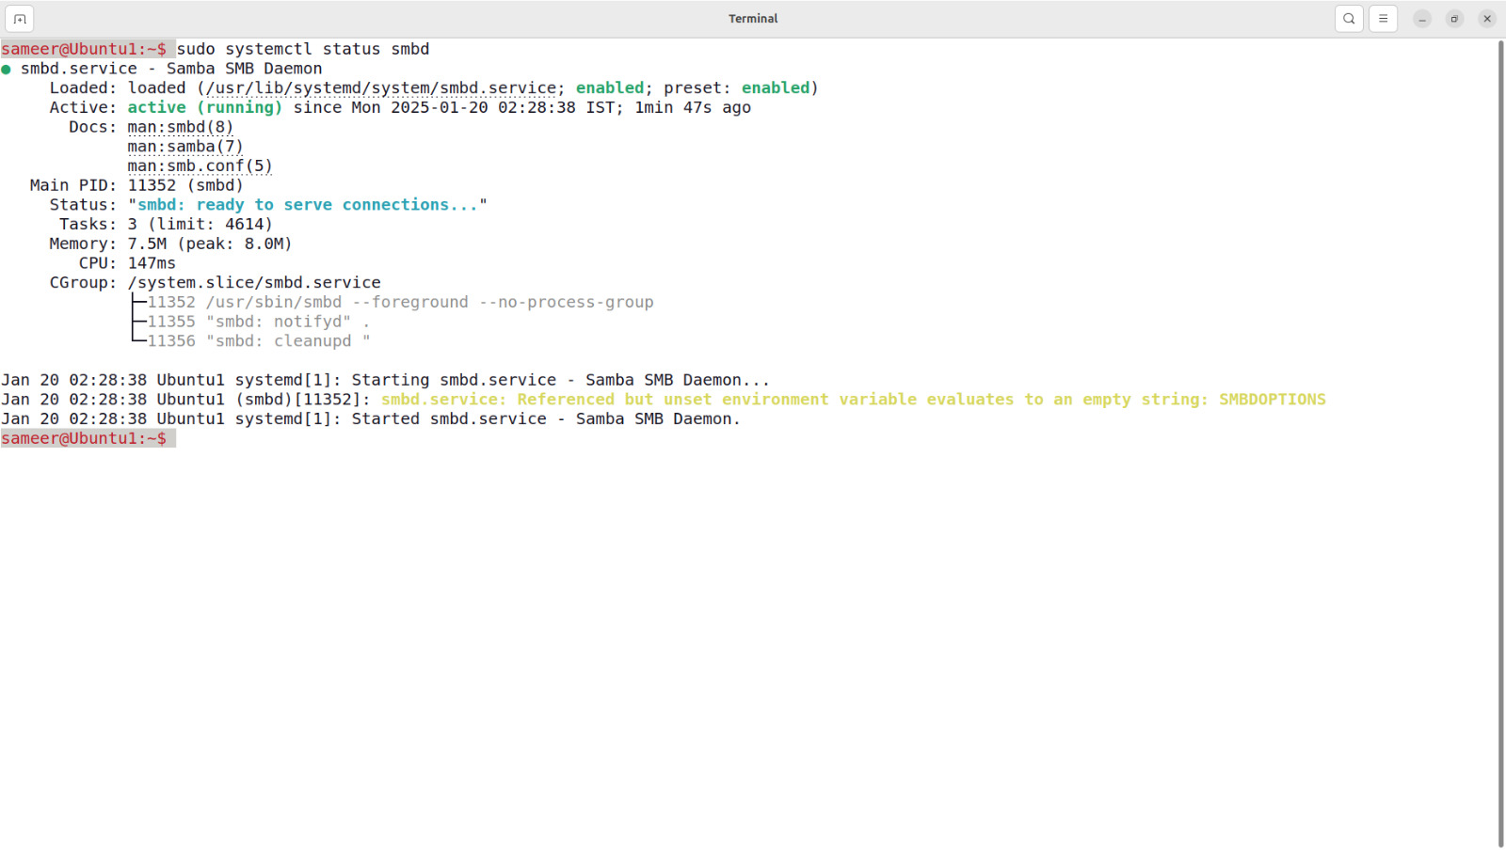

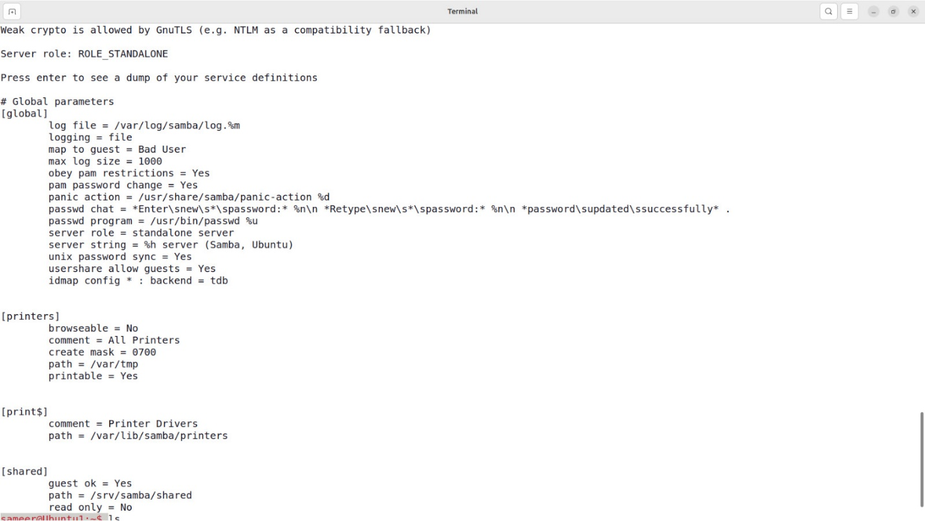

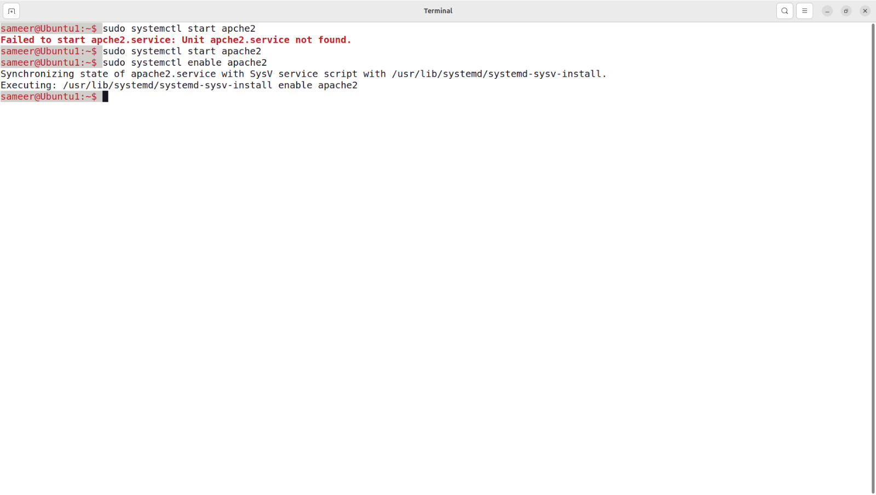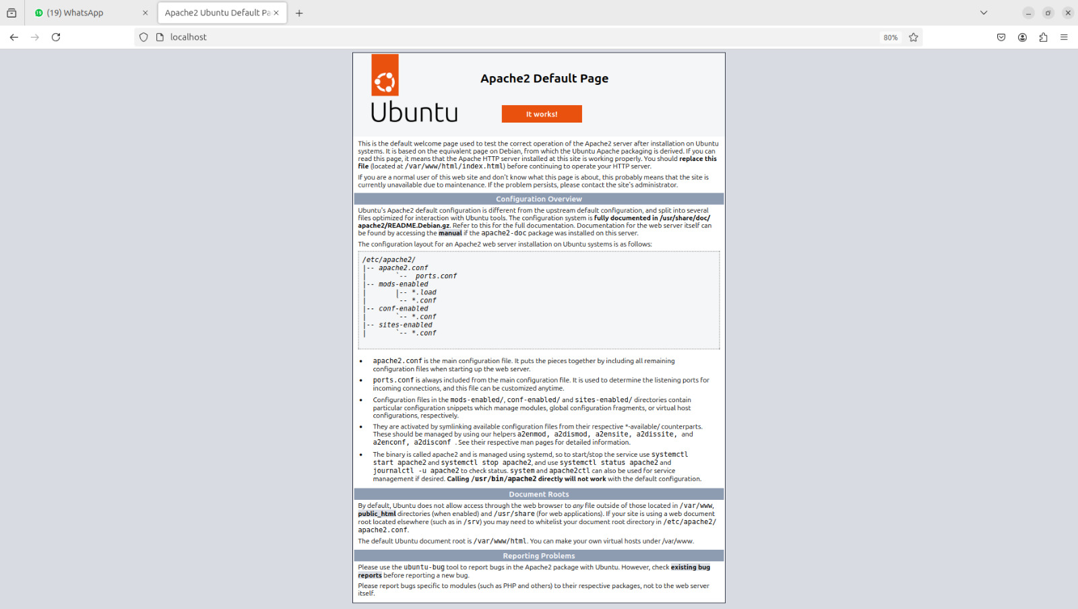

**Q.15 Implementation of DNS, LDAP services**

**DNS (BIND)**: BIND provides the essential DNS service for resolving domain names to IP addresses, allowing networked devices to access each other using human-readable names.

**DNS (BIND) Installation and Configuration**

**Step 1: Install BIND (DNS Server)**

BIND (Berkeley Internet Name Domain) is the most widely used DNS server on Unix/Linux systems.

For **Debian/Ubuntu-based** systems:

sudo apt update

sudo apt install bind9 bind9utils bind9-doc -y

**Step 2: Configure BIND**

1. **Main Configuration File**: Edit the main DNS configuration file, /etc/bind/named.conf.local for Ubuntu or /etc/named.conf for CentOS.

sudo nano /etc/bind/named.conf.local # Ubuntu

1. Add a zone configuration to define the domain (example example.com):

zone "example.com" {

type master;

file "/etc/bind/db.example.com";

};

1. **Create a Zone File**: Create the file that holds the DNS records.

sudo nano /etc/bind/db.example.com

Example content:

$TTL 604800

@ IN SOA ns1.example.com. admin.example.com. (

2021010101 ; Serial

604800 ; Refresh

86400 ; Retry

2419200 ; Expire

604800 ) ; Minimum TTL

@ IN NS ns1.example.com.

ns1 IN A 192.168.1.10

www IN A 192.168.1.20

1. **Restart the BIND Service**:

sudo systemctl restart bind9 # Ubuntu

sudo systemctl restart named # CentOS

**Step 3: Test the DNS Server**

You can use the dig or nslookup command to test the DNS server:

dig @localhost example.com

**LDAP (OpenLDAP)**: LDAP is a directory service protocol used to store and manage user credentials, authentication, and other directory information in a centralized database.

**LDAP Server (OpenLDAP) Installation and Configuration**

**Step 1: Install OpenLDAP Server**

OpenLDAP is the most commonly used LDAP server on Linux systems.

For **Debian/Ubuntu-based** systems:

sudo apt update

sudo apt install slapd ldap-utils -y

**Step 2: Configure OpenLDAP Server**

1. **Reconfigure OpenLDAP** (for Debian/Ubuntu):

sudo dpkg-reconfigure slapd

During the configuration, you will be prompted to provide the domain name (e.g., example.com), administrator password, and other settings.

1. **Start and Enable OpenLDAP**:

sudo systemctl start slapd

sudo systemctl enable slapd

**Step 3: Configure LDAP Schema and Data**

1. **Add an LDAP entry**:
   * Create a .ldif file for the base structure of your directory (e.g., base.ldif):

dn: dc=example,dc=com

objectClass: dcObject

objectClass: organization

o: Example Corp

dc: example

* + Add this entry to the LDAP directory:

sudo ldapadd -x -D cn=admin,dc=example,dc=com -W -f base.ldif

**Step 4: Add User and Group Entries**

1. Create another .ldif file for a user (e.g., user.ldif):

dn: uid=john,ou=users,dc=example,dc=com

objectClass: inetOrgPerson

uid: john

sn: Doe

givenName: John

cn: John Doe

displayName: John Doe

userPassword: secret

1. Add the user to the LDAP directory:

sudo ldapadd -x -D cn=admin,dc=example,dc=com -W -f user.ldif

**Step 5: Verify LDAP Directory**

Use ldapsearch to verify the entries in your LDAP directory:

ldapsearch -x -b dc=example,dc=com

**Q.16 Study & installation of Firewall &amp; Proxy server**

**1. Firewall Installation and Configuration**

A **Firewall** is a security system that monitors and controls incoming and outgoing network traffic based on predetermined security rules. It acts as a barrier between a trusted internal network and untrusted external networks, such as the internet.

**Types of Firewalls**

* **Packet-filtering Firewall**: Inspects packets at the network layer and filters traffic based on rules.
* **Stateful Inspection Firewall**: Tracks the state of active connections and makes decisions based on the state of the connection.
* **Proxy Firewalls**: Acts as an intermediary between clients and servers.
* **Next-Generation Firewalls (NGFW)**: Combines traditional firewall capabilities with advanced security features like intrusion detection and application filtering.

**Step 1: Install Firewall (UFW - Uncomplicated Firewall) on Ubuntu/Debian**

UFW is a simple frontend for managing firewall rules. It is easy to use and suitable for most users.

**For Ubuntu/Debian**:

sudo apt update

sudo apt install ufw -y

**Step 2: Configure Firewall Rules**

1. **Enable UFW**:

sudo ufw enable

1. **Allow SSH**: Allow SSH to ensure you don't lock yourself out of the server.

sudo ufw allow ssh

1. **Allow Specific Ports**: To allow HTTP and HTTPS traffic:

sudo ufw allow 80,443/tcp

1. **Check UFW Status**:

sudo ufw status verbose

1. **Deny All Incoming Traffic and Allow Outgoing**:

sudo ufw default deny incoming

sudo ufw default allow outgoing

1. **Enable Logging**: Enable logging to monitor firewall activity:

sudo ufw logging on

**Step 3: Restart UFW:**

sudo systemctl restart ufw

**Step 4: Verify Firewall:**

sudo ufw status

**2. Proxy Server Installation and Configuration**

A **Proxy Server** acts as an intermediary between client devices and the internet, allowing users to request resources indirectly. Proxy servers are typically used to improve security, manage network traffic, or cache data.

**Types of Proxy Servers**

* **Forward Proxy**: Clients use the proxy server to access external resources.
* **Reverse Proxy**: The proxy server handles requests from the outside world and directs them to internal resources.
* **Transparent Proxy**: A proxy that doesn't modify requests or responses and is typically used for monitoring.
* **Anonymous Proxy**: Hides the identity of the client.

**Step 1: Install Squid Proxy Server**

**Squid** is one of the most widely used proxy servers for Linux-based systems.

**For Ubuntu/Debian**:

sudo apt update

sudo apt install squid -y

**Step 2: Configure Squid Proxy Server**

1. **Edit the Squid Configuration File**: The main configuration file for Squid is located at /etc/squid/squid.conf.

Open it with a text editor:

sudo nano /etc/squid/squid.conf

1. **Allow Access**: To allow access from a specific subnet, find the line that reads #http_access allow localhost and add an additional line for your network.

acl localnet src 192.168.1.0/24 # Replace with your network IP range

http_access allow localnet

1. **Set Proxy Port**: The default port for Squid is 3128. You can configure it in the http_port section:

http_port 3128

1. **Enable Caching**: To enable caching, ensure that the following lines are not commented out (remove the # if present):

cache_dir ufs /var/spool/squid 100 16 256

1. **Configure Access Control Lists (ACLs)**: If you want to allow or block access to specific websites, you can configure ACLs:

acl blocked_sites dstdomain .example.com

http_access deny blocked_sites

**Step 3: Restart Squid Server**

Once configured, restart Squid to apply the changes:

sudo systemctl restart squid

**Step 4: Verify Proxy Server**

1. **Test Proxy**: Set your browser or system to use the Squid proxy (usually localhost or the server's IP address and port 3128).
2. **Check Squid Logs**: Squid logs requests and activities in /var/log/squid/access.log.

tail -f /var/log/squid/access.log

**Step 5: Enable Squid to Start on Boot**

sudo systemctl enable squid